**Guidelines and Procedures For PCS Title I Schools**



**2024-2025**

**School Year**

**Table of Contents**

**Guide to Use** 4

**Title I Information** 5

Federal Programs Staff6

Title I Schools 7

Low Performing Schools 8

ESSA Highlights 9

Title I Comprehensive School Wide Planning 12

Title I Components Clarification 15

Title I Program Calendar 18

**School Improvement**  20

12 Indicator Process 21

12 Key Indicators 22

TSI-AT Schools 23

TSI-CU Schools 24

NCSTAR 25

**Title I Guidelines/Guidance** 26

Guidelines for Using Title I Funds 27

Field Trip Guidance 29

Transportation 31

**Budget Information/Allowability** 32

Title I Budget 33

Title I Allowability Cost Guide 38

Title I Funding 43

**Purchasing Guidelines/Reimbursements** 44

Title Purchasing Guidelines 45

Purchase Order Submission Process 47

Things to Remember 48

Parent Reimbursement Checklist 50

Workshop/Reimbursement Checklist 51

**Contract, Notice to Pay, and Timesheets** 52

Title I Contracts 53

Contract Reminders 55

Sample Contracts 56

Title I Timesheets 57

Notice to Pay Checklist 59

**Finance Codes**  60

Budgeting Codes 61

**Parent and Family Engagement** 63

Parental Family Engagement Activities 64

Parent Engagement Policy 65

Parent Family Engagement Policy Requirements 69

**Forms and Sample Documents** 70

Title I Prioritized Plan Template 71

Semi-Annual Blanket Certification: Pre-K Example 74

Semi-Annual Blanket Certification: Federal 05 Example 75

Title I Mid-Year Website Checklist 76

Title I End-of-Year Website Checklist 79

Sample Title I (050) Allocation Summary 82

Request to Use Federal Funds Form 83

Move Money Form 84

Purchase Order Review Form 85

Sample Purchase Order: Supply Items 86

Sample Purchase Order: Parent Engagement Reimbursement 87

Estimate of Travel Form 88

Expense Reimbursement Form 89

Sample Copy of Employee’s Timesheet 90

Parent Engagement Plan Worksheet 91

Parent Engagement Plan 93

Sample Parent Engagement Policy 95

Sample Elementary School Brochure 98

Sample Middle School Brochure 99

Parent Engagement Meeting Sign-in Sheet 100

Sample Parent Engagement Evaluation 101

**Guide to Use**

This guide was created to answer questions that administrators, office staff, teachers, and others may have regarding compliance to federal guidelines as they relate to the operation of Title I programs. General information is provided in the enclosed sections, followed by forms referenced in the guide. Title I and Pitt County Schools’ guidelines are constantly changing. Please note that the contents are current to the time of publication. Updates will be provided as appropriate.



**Title I Information**



**Federal Programs Office Staff**

**Dr. Shannon Cecil**

[cecils1@pitt.k12.nc.us](mailto:cecils1@pitt.k12.nc.us)

Federal Programs Director

252.695.7950

|  |  |
| --- | --- |
| **Shonda Adams**  ESL Testing Specialist  [adamss2@pitt.k12.nc.us](mailto:adamss2@pitt.k12.nc.us)  252.695.7953 | **Hannah Butler**  Coordinator of Global Education  [butlerh@pitt.k12.nc.us](mailto:butlerh@pitt.k12.nc.us)  252.695.7957 |
| **Shanell Whitaker**  Federal Programs  Office Manager  [pitt.k12.nc.us](mailto:carterl@pitt.k12.nc.us)  252.695.7951 | **Patricia Cox**  Title I Specialist  [coxp@pitt.k12.nc.us](mailto:coxp@pitt.k12.nc.us)  252.695.7956 |
| **TBD**  MEP Recruiter  [@pitt.k12.nc.us](mailto:kellyp@pitt.k12.nc.us)  252.695.7954 | **Twanda Staton**  Parent Engagement Coordinator  statont2@pitt.k12.nc.us  252.695.7952 |
| **Karen Capozzi**  Federal Grants Financial Analyst  [capozzk@pitt.k12.nc.us](mailto:capozzk@pitt.k12.nc.us)  252.830.4250  252.830.4262 (fax)  1717 West Fifth Street  Greenville, NC 27834 | Title I at SFMHS - South Fort Myers High School |

**Title I Schools**

**2024-2025**

A.G. Cox (6-8) Ayden Elem. (PK-5) Ayden Middle (6-8)

Belvoir (PK-5) Bethel (PK-8) Chicod (K-8)

C.M. Eppes (6-8) Creekside (K-5) Eastern (K-5)

E.B. Aycock (6-8) Elmhurst (K-5) Falkland (K-5)

Farmville Middle (6-8) Grifton (PK-8) G.R. Whitfield (PK-8)

H.B. Sugg (PK-2) Lakeforest (PK-5) Northwest (PK-5)

Pactolus (PK-8) Ridgewood (K-5) Sam D. Bundy (3-5)

South Greenville (PK-5) Stokes (K-8) Wahl-Coates (PK-5)

Wellcome (6-8) W.H. Robinson (K-5) Wintergreen Pri. (K-2)

Wintergreen Intermediate (3-5)

Title I Low Performing Schools (17)

Ayden Middle (6-8)

Belvoir Elementary (K-5)

Bethel School (K-8)

CM Eppes (6-8)

Creekside Elementary (K-5)

Eastern Elementary (K-5)

E B Aycock (6-8)

Falkland Elementary (K-5)

Farmville Middle (6-8)

Grifton School (K-8)

Lakeforest Elementary (K-5)

Northwest Elementary (K-5)

Pactolus (K-8)

Sam Bundy Elementary (3-5)

South Greenville Elementary (K-5)

Wahl-Coates Elementary (K-5)

Wellcome Middle School (6-8)

**Student Succeeds Act (ESSA) Highlights**

*The President of the United States signed the Every Student Succeeds Act (ESSA) bill into law on December 10, 2015. The Elementary and Secondary Education Act (ESEA) was eight years overdue for reauthorization, and the ESSA is a critical step forward. Here are some (but not all) aspects of the new law:*

**General**

* It places many limitations on the authority of the US Secretary of Education and this includes the inability to require additions or deletions to a state’s academic content standards or to prescribe specific goals of progress, specific assessments, weights of measures or indicators, etc.
* The U.S. Department of Education (USED) will still need to issue regulations but they cannot add new requirements that go beyond what is required in the law.
* All current ESEA Flexibility Waivers will be null and void as of August 1, 2016. However, any schools currently identified as priority and focus schools must be maintained for the 2016-17 school year.

**State Plan**

* There currently is no timeline established for when the new regulations will be issued or by when and how states will submit their plans to the USED.
* It requires involvement of various stakeholders including timely and meaningful consultation with the governor in the development of the state’s plan. The governor must be given 30 days to sign the plan, but it can be submitted to the USED after the 30 days even if the governor does not sign it.
* Implementation of new state plans (once approved by the USED) will start with the 2017-18 school year.

**Assessments, Accountability and Reporting**

* It maintains annual assessments in grades 3-8 and high school.
* It reaffirms that states are in control of their standards (which must be challenging) and assessments.
* It sets parameters for a state’s accountability systems, but gives each state the flexibility to design a school accountability system that best meet the needs of the students in the state. This will include the issue of “n-size” for subgroup accountability.
* It eliminates the phrase “adequate yearly progress” (AYP).
* It maintains a 1% cap on students with the most significant cognitive disabilities, but applies the cap to the number of these students taking alternate assessments and not to capping the percentages of these students being deemed proficient for accountability purposes as under the former law. If an LEA exceeds the 1% cap, it will have to justify it to the state education agency.
* It provides for innovative assessment pilots at the state level so states can research new and improved methods of measuring student progress from year to year. Up to seven (7) states may be selected but that number could increase over time. It will be up to the Secretary of Education to determine the application process and timeline for submission to be one of the pilot states.
* The accountability plans must include goals for academic indicators (improved academic achievement on State assessments, a measure of student growth or other statewide academic indicator for elementary and middle schools, graduation rates for high schools, and progress in achieving proficiency for English Learners) and a measure of school quality and student success (examples include student and educator engagement, access and completion of advanced coursework, postsecondary readiness, school climate and safety). Participation rates on the assessments must also be included in the plan.
* Students with limited English proficiency will be allowed to remain in the English Learner (EL) subgroup for up to four (4) years after exiting the EL classification. This prevents the EL subgroup from always having students with the lowest levels of English proficiency for accountability purposes.
* It maintains many reporting requirements including the State Report Card (SRC). SRC data are expanded to include information on homeless students, foster youth, and students of parents on active duty in the military, information on acquisition of English proficiency by English Learners and professional qualifications of teachers.

**Teacher Quality**

* It gives states the flexibility to work with local stakeholders to determine how educators should be evaluated and supported each year.

**District and School Interventions**

* There is no set of required federal sanctions, but interventions used in schools needing assistance and support must be **evidence-based.**
* States will have to identify, at a minimum, the lowest 5% of Title I schools and high schools with graduation rates lower than 67%. These are the schools that are part of Comprehensive Support and Improvement (CSI).
* LEAs must develop and implement CSI plans for lowest-performing schools –
* States must identify schools with consistently underperforming subgroups for Targeted Support and Improvement (TSI).

**Funding and Formulas**

* It eliminates the federal School Improvement Grants (SIG), but allows states to reserve 7% of Title I funds to make grants available to low-performing schools.
* A portion of State Assessment grants will be made available as a separate allocation to states to conduct audits of state or local assessments as a way to reduce redundant assessments. It combines some 50 programs into a big block grant under Title IV.
* Finally, it authorizes a Preschool Development Grants Program through the Department of Health and Human Services.

**Title I Comprehensive School-wide Planning**

**SCHOOL**

**in consultation with**

**LEA**

**PARENTS**

**COMMUNITY**

**TECHNICAL**

**ASSISTANCE PROVIDER**

Entire school community responsible for success and growth of every student—”No Excuses”

**5-Step Process**

1. Establish the Title I team

2. Clarify the vision for reform

3. Create a school profile

4. Identify data sources

5. Analyze the data

**Analyze and review the existing plan**

* Describe how the school will carry out each of the required school wide components
* Describe how the school will use Title I resources and other resources to carry-out the school wide components
* Include a list of State and local programs the school will consolidate in the school wide program
* Be evaluated annually—looking at both program implementation and achieved results
* Be revised as necessary to ensure continuous student improvement

**Identify the 10 school wide components in your plan**

Title I section 1114(b)(1)]

1. Comprehensive needs assessment summary

2. School reform strategies

3. Highly qualified personnel

4. High quality and ongoing professional development

5. Strategies to attract and retain highly qualified staff

6. Parent involvement

7. Transition strategies

8. Teacher involvement in assessment use

9. Instructional activities for students experiencing difficulty

10. Coordination/integration of federal, state, and local

services/programs

**Focus on High Student Achievement**

* Include school vision and mission
* Address identified educational priorities
* Develop in collaboration with other school programs (e.g., EC, AG, grant-funded, individual school initiatives
* Address areas that impact student achievement (e.g., student needs, curriculum and instruction, professional development, family and community involvement, school context and organization)

**High Expectations**

* Work hard to succeed—both teachers and students
* Challenge students to think more deeply, apply new knowledge and skills, and become self-motivated learners
* Challenge each staff member to believe in each student’s ability to achieve to high standards
* Focus on intensive, early intervention to bring students up to grade level
* Provide opportunities for students to build meaningful relationships with adults
* Write **S**.**M**.**A**.**R**.**T**. goals

**S**: Specific (clear and explicit)

**M**: Measurable (accomplishment)

**A**: Attainable (realistic and controllable)

**R**: Relevant (related to identified needs)

**T**: Time bound (beginning, interim, end)

**Data-driven Instruction**

* Use data to identify students’ strengths and weaknesses
* Use multiple data sources (profiles, surveys, formal and informal assessments, student work samples) to make informed decisions
* Use data to make informed decisions and determine areas of need
* Use multiple daily and weekly student assessments for ongoing data collection
* Focus on mastery by monitoring student progress using assessments to calibrate and retool
* Adjust teaching strategies to meet students’ needs based on the data

Analyze the

**Analyze the Data**

* Establish a process to review the data
* Determine any gaps between the vision and the current findings
* Summarize the data
* Draw conclusions
* Share the findings with the educational community
* Prioritize the needs
* Determine how to meet the needs
* Build an ongoing plan to facilitate continuous planning

Comprehensive

**Professional Learning**

* Seek opportunities to acquire new content knowledge and instructional skills
* Share what works—skills and strategies—with one another
* Establish learning communities—vertical teams made up of teachers, aides and staff, cutting across grade levels
* Include culturally responsive training in content and skills
* Collaborate with colleagues to identify solutions to barriers

**Parent Outreach**

* View parents as critical partners in the educational process
* Solicit and facilitate parental participation
* Create opportunities for parents to join in the life of the school and share learning experiences with their children
* Offer parents opportunities to collaborate with the school both when planning and making decisions about their child
* Create a climate of cooperation between school, parents, and the community

**Can-do Spirit**

* Commit to continuous student progress
* Convey genuine caring
* Honor students and their heritages
* Extend learning time
* Give students access to timely, effective, extra instruction if necessary
* Use rigorous and challenging content standards
* Accelerate and enrich the curriculum
* Teach them to learn with understanding
* Provide opportunities to excel in areas of special interest

**Title I Components Clarification**

**Comprehensive Needs Assessment**

* Establish a planning team of educators, parents and community members to review school needs and create a vision for school-wide reform each year
* Use school data to determine areas of strength and weakness and plan reform
* Implement best practices that support school improvement and school needs
* Your parent representative must be a non-PCS employee and is a required member of the team

**School Reform Strategies**

* Identify low performing areas and strategies used to address those areas
* Instructional strategies that support school wide reform or improvement (Blended Learning, Instructional Coaches, MTSS, etc.)
* Procedures to identify low performing students, strategies need for those students, how progress will be monitored, and how parents are informed of progress.
* Specific strategies used to decrease achievement gap
* Describe availability of extended day opportunities that address increasing student achievement (tutoring/remediation, before, after or during)
* Describe procedure for identifying and targeting minority, poverty and language limited students and strategies used to address the needs of these populations.
* If you are an ATSI school, you must address what specific strategies you will use to improve subgroup performance in your identified area.

**Highly Qualified Staff**

* Identifying professional development activities to enhance instructional practices
* Plan for all provisionally licensed teachers and teacher assistants to become highly qualified
* Plan to ensure that all staff is HQ by monitoring staff placement

**Teacher Recruitment and Retention**

* How you use assessment data to place highly qualified teachers in areas of need, including the use of “reduced class size” positions.
* Strategies used to recruit/retain highly qualified teachers
* Recruitment initiatives at the schools level in terms of climate issues, administrative support for teachers (planning, staff development, lead teacher and/or mentor support) and any incentive program that may exist.

**Grade Transition: PreK – K, Elem., Middle, and/or Middle-High School**

* Describe your transition strategies and how these transition entities work with one another (ex. How do you plan activities at your school to help students transition from one grade to another)
* Programs that transition from one grade to the next (PBIS, etc.)
* All Title I Schools must have evidence of a grade transition plan.

**HQ Staff Development**

* Target staff development that address specific subgroups
* School wide training for all certified teachers and teacher asst.
* Supports research based strategies/district goals

**Instructional At-Risk/Assistance**

* Lists steps or provide copy of procedures to identify students of placement in Exceptional Children’s Programs, ESL/LEP, etc.
* Describe professional development activities planned that will assist teachers in teaching and addressing needs of student s with identified needs and different learning styles.
* Discuss how technology and extended day opportunities are used to address needs of this population
* Strategies used to improve instruction with at-risk students
* Programs that address the needs of at-risk student population
* Include an overview of your school’s specific MTSS process

**Teacher Involvement/Input**

* Describe how teachers use data to drive instruction. Analyze data and assessments to improve instruction.
* Teachers developing assessments using technology to improve student performance.
* Teacher knowledge of using different assessment with students

**Federal, State and Local Support**

* Describe collaborations you have with other programs, grants, agencies or local/civic or church organizations.
* Local or district wide initiatives/programs
* Programs supported by DPI
* Strategies are supported by federal, state or local funds

**Parent Engagement**

* Events that promote student involvement across the curriculum
* Annual Title I meeting activities
* Activities that promote a positive home/school relationship
* Strategies that enhance communication between school and parents
* All Title I engagement events must include a parent education component

**Title I School-Wide Program Calendar**

|  |  |
| --- | --- |
| **June** | **July** |
| * Turn in:   -Title I Budget (Proposed)  -Parent Involvement Plan  -Parent Involvement Policy  -Parent Involvement Requirements  -Statement of Assurance  -Principal Attestation Form  - Title I School Brochure (Rough Draft)  -Parent Involvement Workshops  (Dates/Times) for 2024 - 2025 year   * Title I Inventory is due * **Final Title I Website Review** * Title I Principal and Bookkeeper Meeting * Annual program review * Submit Semi-Annual Certification Form * Submit Student Success Comprehensive Plan Report in NCSTAR * Conduct & submit minutes from 2 monthly meetings. * Work on Needs Assessment | * Store files-Keep Title I documents for 5 years * Update Title I Plan based on any retesting/summer data * **Read Title I Guidelines/Procedures** * Set up meetings w/Federal Programs Director if needed * Prioritize PD Needs * Submit your Comprehensive Needs Assessment to the Federal Programs Office * Begin updating goals and making changes in personnel in NCSTAR * Planning budget worksheet due on 7/19/24 |
| **August** | **September** |
| * Submit Final Title I Budget w/any revisions (Aug. 19th) * Update NCSTAR’s goals and strategies * Send home Parent Notification-Priority/Focus School * Send home Title I School Brochures * Select Title I Contact * Update Budget sheet with correct teacher names and changes before school starts * Catalogue Title I Purchases * Select teacher to attend your prioritized PD * Submit Focus School Plan * Leadership Team Professional Development * Conduct & submit minutes from 2 monthly meetings. * Disseminate District Compacts to families | * Title I Contact Meeting * Schools Conduct Annual Title I Parent Meeting (Must be held by Sept. 30th) * Review your Prioritized Plan and make any necessary changes * Schools submit School Improvement Plans – ALL schools * ESL Classes begin after testing (Contact Federal Programs Director and ESL Contacts) * Send home letters to parents about HQ Status of teachers/TA’s (Parent’s Right to Know) * Catalogue Title I purchases * Begin uploading Title I documents to website * Conduct & submit minutes from 2 monthly meetings. |
| **October** | **November** |
| * Submit verification letter to Title I office of the Parents Rights to Know letter distribution * Submit verification of non-HQ letter documentation * Technical Assistance for Focus/Priority School * Catalogue Title I purchases * Upload Title I documents to website * Conduct & submit minutes from 2 monthly meetings. * Schools are notified of ATSI status * Schools submit updated ATSI and/or LP letters to the Office of Federal Programs * Ensure all 12 Key Indicators are assessed and action steps are created for your 3 prioritized indicators * ATSI schools must have action steps for A4.01 and D1.02 | * **Submit any Budget Revisions** * Update Title I Plan * Catalogue Title I purchases * Upload documents on website * Upload Title I documents to website * Conduct & submit minutes from 2 monthly meetings. * ATSI Notification letters distributed directly and indirectly by Nov. 30th * Submit verification of Low Performing or ATSI letters * Update strategies/evidence in NCSTAR |
| **December** | **January** |
| * All school submit Student Success Comprehensive Plan Report in NCSTAR * Catalogue Title I purchases * Review District Equity Plan in your Staff Meeting * Upload Title I documents to website * **First Title I Website Review will be conducted. – any schools that are not in compliance will not be allowed to spend Title I fund until they bring their websites into compliance.** * Conduct & submit minutes from 2 monthly meetings. * **50% of Title I funds should be spent.** | * Mid-Year Title I Principal and Bookkeeper Meeting * Final PO requisitions for computers * **75% of Title I funds should be spent** * Submit Semi-Annual Certification Forms * Update Title I Plan * Review Title I Spending in your SIT Meeting * Catalogue Title I purchases * Upload documents to website * Conduct & submit minutes from 2 monthly meetings. |
| **February** | **March** |
| * Spend Title I Funds before deadline * **Submit any final Budget Changes** * Update Title I Plan * Catalogue Title I purchases * Upload Title I documents to website * Conduct & submit minutes from 2 monthly meetings. | * Assistant Principal Meeting * Submit Final Purchase Order by the March 21st deadline * Catalogue Title I purchases * Upload Title I documents to website * Conduct & submit minutes from 2 monthly meetings. * Begin reviewing Title I Brochures for changes/revisions for the 2025-2026 school year |
| **April** | **May** |
| * Catalogue Title I purchases * Catalogue Title I purchases * Schools need to notify Federal Programs of summer programs * Upload Title I documents to website * Conduct & submit minutes from 2 monthly meetings. * Update strategies in NCSTAR * Begin working on a prioritized plan for the 2025-2026 school year. | * Receive Title I Planning Allocation * Analyze parent involvement attendance * Begin planning for 2025-2026 school year * Catalogue Title I purchases * Upload Title I documents to website * Conduct & submit minutes from 2 monthly meetings. |

**School Improvement**



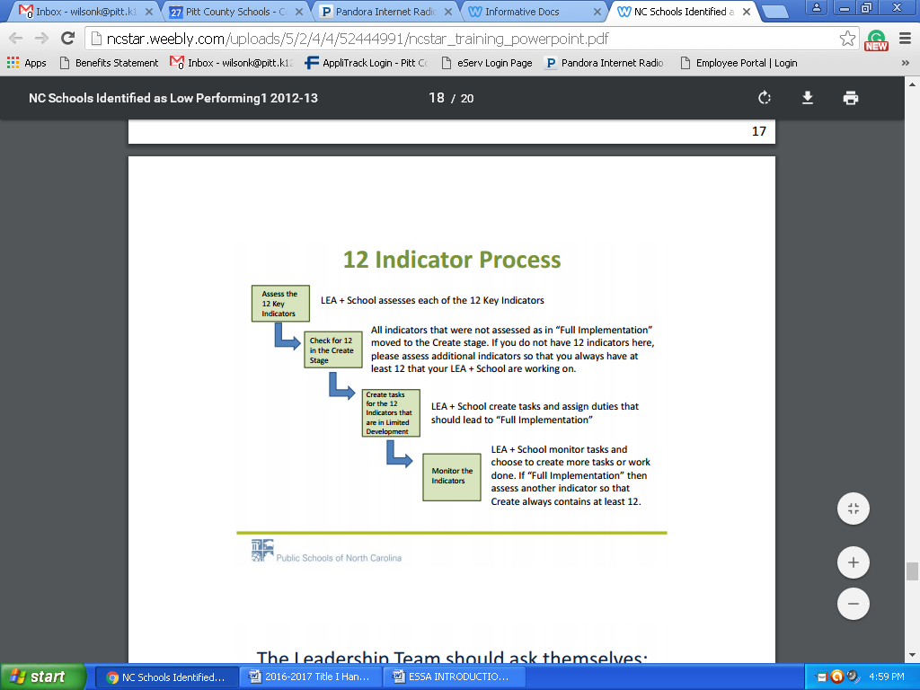

**The 12 Key Indicators**

* All teachers employ effective classroom management and reinforce classroom rules and procedures by positively teaching them. (A1.07)
* Instructional Teams develop standards-aligned units of instruction for each subject and grade level. (A2.04)
* The school implements a tiered instructional system that allows teachers to deliver evidence-based instruction aligned with the individual needs of student across all tiers. (A4.01)
* All teachers are attentive to students’ emotional states, guide students in managing their emotions, and arrange for supports and interventions when necessary. (A4.06)
* The school develops and implements consistent, intentional, and on-going plans to support student transitions for grade-to-grade and level-to-level. (A4.16)
* A Leadership Team consisting of the principal, teachers who lead the Instructional Teams, and other key professional staff meets regularly (twice a month or more for an hour each meeting) to review implementation of effective practice. (B1.03)
* The school has established a team structure among teachers with specific duties and time for instructional planning. (B2.03)
* The principal monitors curriculum and classroom instruction regularly and provides timely, clear, constructive feedback to teachers. (B3.03)
* The LEA/School regularly looks at school performance data, aggregated classroom observation data, and uses the data to make decisions about school improvement and professional development needs. (C2.01)
* The LEA/School has established a system of procedures and protocols for recruiting, evaluating, rewarding, and replacing staff. (C3.04)
* The LEA/School has aligned resource allocation (money, time, human resources) within each school’s instructional priorities. (D1.02)
* The school regularly communicates with parents (families) about its expectations of them and the importance of the curriculum of the home (what parents can do at home to support their children’s learning). (E1.06)

**Targeted Support and Improvement Schools (TSI)**

Additional Targeted Support - 2022-2023 Identification List

|  |  |  |
| --- | --- | --- |
| **School Name** | **Cohort** | **Qualifying Subgroups for TSI-AT**  **EDS = Economically Disadvantaged Students**  **ELS = English Learners**  **SWD = Students with Disabilities** |
| AG Cox Middle | SWD-2 | SWD |
| Ayden Middle | SWD-2 | SWD |
| CM Eppes Middle | SWD-2 | SWD |
| Creekside Elementary | SWD-2 | SWD |
| Eastern Elementary | SWD-2 | SWD |
| EB Aycock Middle | SWD-2 | SWD |
| Farmville Middle | SWD-2 | SWD |
| Grifton | SWD-1 | SWD |
| HB Sugg Elementary | SWD-1 | SWD |
| Lakeforest Elementary | SWD-2 | SWD |
| Pactolus | SWD-2 | SWD |
| WH Robinson Elementary | SWD-1 | SWD |
| Sam D Bundy Elementary | SWD-2 | SWD |
| Wellcome Middle | SWD-2 | SWD |

**Targeted Support and Improvement Schools (TSI)**

Consistently Underperforming Subgroups - 2023-2024 Identification List

|  |  |
| --- | --- |
| **School Name** | **Qualifying Subgroups for TSI-AT**  **EDS = Economically Disadvantaged Students**  **ELS = English Learners**  **SWD = Students with Disabilities** |
| AG Cox Middle | SWD |
| Ayden Elementary | SWD |
| Ayden Middle | SWD |
| CM Eppes Middle | SWD |
| Creekside Elementary | SWD |
| Eastern Elementary | SWD |
| EB Aycock Middle | SWD |
| Farmville Middle | SWD |
| Grifton | SWD |
| HB Sugg Elementary | SWD |
| Hope Middle | SWD |
| Lakeforest Elementary | SWD |
| Pactolus | SWD |
| WH Robinson Elementary | SWD |
| Sam D Bundy Elementary | SWD |
| South Central | SWD |
| South Greenville Elementary | BLCK, EDS |
| Wellcome Middle | SWD |

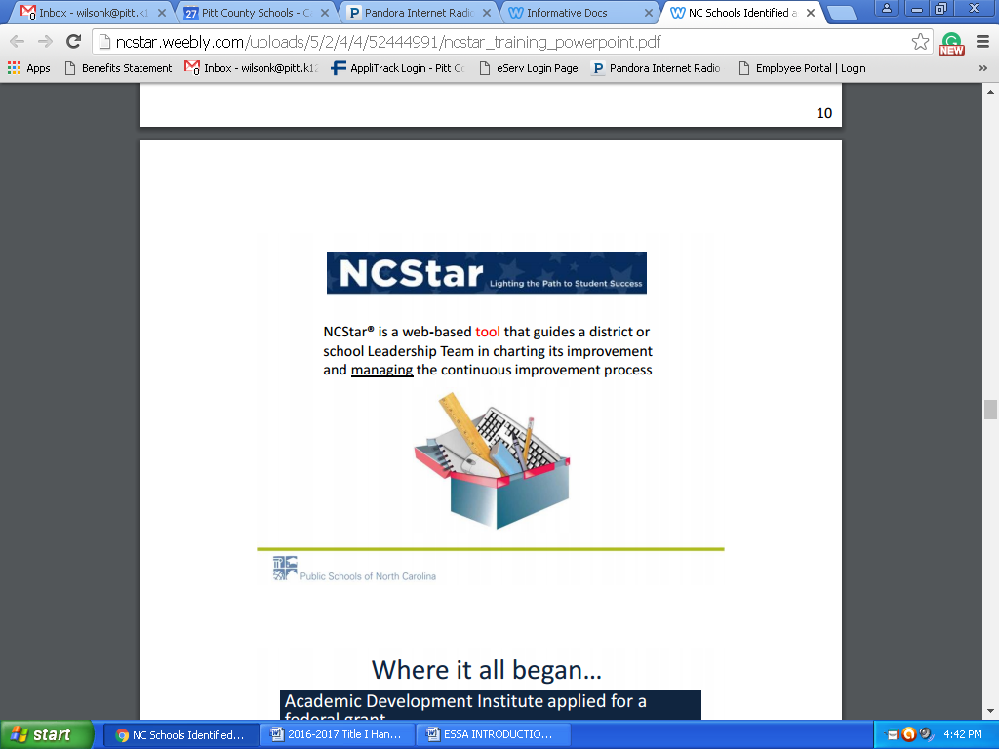

* Title I Schools will use NCSTAR to monitor the School Improvement Planning for their school. Two meetings should be held each month to discuss the school indicators.
* Meeting minutes must be recorded in NCSTAR.
* All Low Performing Schools will complete the Comprehensive Progress Report in the Fall and Spring in NCSTAR
* ATSI schools must have action steps, in goals A4.01 and D1.02, aligned with improving their subgroup area of identification & should regularly report/update their progress towards meeting that goal in NCSTAR.
* Action steps should list specific strategies they will utilize in the action step.

**Title I Guidelines/ Guidance**



**Guidelines for Use of Title I Funds**

Title I schools must ensure that funds support efforts to improve performance of all students with particular attention to students who are failing, or at risk of failing to meet at minimum, the NC academic proficiency standards on state academic assessments.

1. Funds may be used to **supplement, not supplant**, other state and local resources for improving the instructional program.
2. All expenditures should be reflected in the School Improvement Plan (SIP) **and** on the Title I Prioritized School Plan, and should have a strong likelihood of impacting the instructional program in the current year. Inappropriate expenditures may require alternative funding sources.

Planning budgets are developed in the spring proceeding the implementation year based on the planning allocation provided to each school. School planning budgets are incorporated into the district application, and submitted to the NC Department of Public Instruction for review and approval. Once approved, adjustments to the budget must be approved by the local School Board and DPI.

Funds allocated during a fiscal year are to be:

1. Expended during the same time period, and with the exception of school improvement funds
2. Do not carry-over at the school level to the next year.
3. Funds from one year’s allocation may not be used to pay for activities occurring in another fiscal year.

**Recommended Expenditures:**

* Instructional Staffing
* Additional classroom teachers
* Resource teachers in core areas
* Extended time programs (before/after school, Saturday, summer) for lowest performing students and related expenses (i.e. tutor salaries, transportation)
* Pre-kindergarten program (salaries, materials, parent involvement, professional development)
* Instructional materials/supplies
* Instructional technology
* Parenting education activities and supplies
* High quality professional development activities and materials

**Plan ahead and always adhere to Finance Department policies and procedures as outlined by Pitt County Schools for all Title I funded expenditures.**

**Please Note**

All Title I schools are required to complete the following documents:

1. Comprehensive Needs Assessment

2. Prioritized Plan

3. School Improvement Plan - NCSTAR

4. Title I Budget Worksheet

5. Principal Attestation Form

6. Parent Engagement Worksheet

7. Parent Engagement Plan

8. Parent Engagement Policy

9. Statement of Assurance

10. Title I Information Checklist

11. Semi-Annual Form

12. Title I School Brochure

13. Title I Website

**Field Trip Guidance**

**Field Trips**

Field trips where specific costs have an academically aligned purpose and are authorized in the programmatic guidelines of the LEA **MAY** be allowed. Field trips that are considered entertainment are not allowed. If the educational field trip is identified as allowable by the federal program guidelines, the justification must be identified in the school improvement plan. The school must maintain appropriate documentation that the educational field trip is reasonable, necessary, and allowable under Title I guidelines. Field trips that are not included in the school budget and school improvement plan PRIOR to the event is unallowable and will result in questioned costs that must be repaid with local/state funds.

**Examples of Potentially Allowable Educational Field Trips**

Examples of appropriate educational field trips that could be allowed if documented within the school improvement plan include:

* Curricular academic activities focused on math, science, and technology, such as service learning, internships, academic competitions (robotics, math, quiz bowl), or science and technology fairs, laboratory and field investigation instruction, used to improve students’ understanding of science objectives.
* Trips to a river, archaeological site, or nature preserve that might include contracting with local science centers, museums, zoos, and horticultural centers for visits and programs.
* Trips to the local library to increase access to high-interest reading materials
* Visits to colleges and universities to encourage interest in the pursuit of higher education

**Unallowable Costs Related to Field Trips**

* Field trips for social, entertainment, or recreational purposes
* Field trips as “rewards” for either behavior or academics
* Field trips that supplant and do not supplement local or state expenditures or activities
* Field trips that are not part of a teacher’s lesson plan or that do not meet the instructional objectives of the federal grant program
* Field trips that are not reasonable in cost or are not necessary to accomplish the objectives of the federal grant program
* Field trips that are not properly documented (as described in the School Improvement Plan)
* Field trips to entertainment or recreational locations that have legitimate educational programs when more than 25% of the time at the location is used for entertainment or recreation of field trip participants

**Meals**

* Meals cannot be paid for with Federal funds

**Substitutes**

* Substitutes for classrooms of teachers who are supervising/chaperoning field trips is allowable IF determined to be reasonable and necessary by the LEA and school/district funds allow from the federal grant program.

**Required Documentation**

* Pre-trip Activities (for example if you are taking students on a college visit you may have activities such as an internet scavenger hunt related to the college or have students to produce a college brochure about the college you will visit.)
* During the Trip: You should have sign-in sheets with what students and adults attended the trip, and students should be documenting their experience. Students can take pictures, create questions they want answered on the trip, keep a journal; these are all examples of how students can document their trip.
* Post Trip Activity: You will need to have a follow-up activity when you return. For example, students could create a poster or brochure, take a quiz, or create another type of presentation.
* **You MUST receive PRIOR APPROVAL before you make any reservations. We will NOT reimburse any trips that are taken without prior approval.**

**Transportation**

**Yellow Buses/Activity Buses**

Title I will pay for transportation when it is used for after school tutoring services. If a yellow bus is used for services, the Transportation Department will invoice the school. The invoice will include all costs associated with yellow buses. The original invoice should be signed by the principal and sent to the Title I department for payment along with a purchase order and roster of students’ who were provided transportation each day.

**Title I Budget Information & Allowability**



**Title I Budget**

**A. Personnel** – As you revise your budget, think about the following:

(See Title I SalaryAllocations)

* Number of teachers paid from Title I
* Salaries of those teachers
* Consider salary exchanges (salary swap). Exchanges may only be used for teachers serving students (not facilitators, counselors, etc.) and must be exchanged with a job-alike person (classroom teacher exchanged for another classroom teacher, not Art or Music teacher).
* If you are replacing a teacher with a Title I teacher that you have swapped, please indicate that on the Interview Recommendation Form or the HR Change Form.
* Amendments to Title I plan may be done twice during the year (once in November and once in February). Please complete a Federal Programs “Move Money Form” when transferring Title I funds to another budget code.
* Before Interview Recommendation Forms can be processed, an updated budget must be sent to Patricia Cox. If you do not send an update budget, the Move Money form, **will not** be approved.
* For the 2024-2025 school year, you will need to use the following on your allocation worksheet:
  + BT1 Salary - $40,000
    - 8% supplement
    - Social Security (7.65%)
    - Retirement (25%)
    - Insurance - $8095
    - Total Cost = $65,399.80
  + Teacher Assistant Salary (7.5 hours) - $24,000
    - Social Security (7.65%)
    - Retirement (25%)
    - Insurance - $8095
    - Total Cost = $39,931.00

**B. Instructional Supplies and Materials**

* Materials purchased with Title I funds must be directly linked to instruction, student achievement, and the Comprehensive School Plan.
* By December, 50% of the school’s Title I instructional supplies and materials should be spent.
* By January, 75% of the school’s Title I instructional supplies and materials amount should be spent.
* Must submit a PO Request form with all PO’s.
* **All purchase orders for materials must be in the Federal Programs Office by March 21, 2025 at 5:00 pm. Title I (050) funds will not be available after this date. (This is spring break week, so please plan accordingly. There will NOT be an extension provided.)**
* Funds will be monitored by the Federal Programs Director monthly.
* Remember, this year’s funds MUST be used for this year’s students.

**C. Use of Title I funds**

* Use Title I funds to **supplement** other fund sources, not to provide district-adopted textbooks, teacher editions, or basic items that are found in classrooms as part of a new classroom equipment and supply setup.
* **Avoid** **using Title I funds for the following:**
  + Copier payment
  + Items for teachers (selected items)
  + Basic classroom supplies such as staples, paperclips, pencils, pens, tape, etc. – these items should be purchased with state instructional funds
  + Food **can only be used** for a Title I Parent Involvement activity. In such case, **an agenda and a dated sign-in sheet for the activity must be attached to the food invoice) Maximum amount to be spent on food is $4.50 per person.** We will NOT reimburse any food expenses if you do not have at least 5 parents to attend the event. (Please note that these 5 parents, must be NON-PCS employees.)
  + Memberships in organizations
  + Payment for professional development activities not identified in Comprehensive Plan or included as part of a district initiative
  + Phone payment (unless for Parent Involvement or at-risk activities)
  + Postage (Not to pay for school’s basic operational postage; can pay postage for at-risk student activities or designated Parent Involvement plan activities)
* Reminder: Items purchased with Title I funds should be for the targeted grade levels: K-5, K-8 or 6-8 (student list should be available for review).
* In order to keep the Federal Programs Office records aligned with the appropriate use of Title I funds and the strategies in the Comprehensive Plan, the following process will take place.
  + If we receive a purchase order or memo that is questionable for payment with Title I funds, we will send an email and ask you to provide justification for the purchase and return it to the Title I office **(Purple).**

**D. Prior Approvals/Purchase Orders**

* All prior approvals and purchase orders for Title I funds (050) must come **FIRST** to the Federal Programs Office.
* A Request to Use Federal Funds Form must accompany all PO’s. (Your PO will be returned to you if this is not included.)
* **Please note, if you spend funds without prior approval you may not be reimbursed!!**
* Purchase Orders for payment and/or reimbursement should include the following information:
  + Name and address of person, school, or business to which payment is due
  + Budget Code Number
  + Memo identifying item and/or title and date of event (if applicable)
  + Name of person(s) (if Purchase Order is for workshop or staff development session)
  + Principal signature
  + Applicable quotes (All purchases must have 2 quotes, purchases above $10,000 must have 3 quotes)

**E. Work Verification Sheets**

* You will review and sign a semi-annual certification of employees paid from Title I funds in January and June of each year.
* If a staff member who works in your school and at no other school is paid partially from Title I funds and partially from a state or local fund source, you may still certify that this person works 100% in your school wide program.
* If a staff member works only part-time at your school and at no other school, you may certify that this person works 100% in your school wide program.
* If a staff member works **at your school and another school,** please **contact me** to see if that staff member should complete a Personnel Activity Report (PAR) each month.

**F. Move Money Form**

* When updating the budget, remember to use a Move Money Form and send updated Budget Plan to Patricia Cox. She will make necessary changes and send you a copy.
* **Move money forms and Budget Plan changes will ONLY be accepted twice a year; once in November and once in February. Please plan accordingly.**

**G. Receipts for Reimbursement**

* When submitting receipts for reimbursement please remember the following:
  + You cannot have any items on the receipt that are not directly related to the event you are requesting reimbursement for.
  + Receipts must be signed.
* When requesting reimbursement for parent events, remember you must attach the following to your Purchase Order:
  + Copy of your signed Request to Use Federal Funds form
  + Copy of the parent invitation for your event
  + Copy of the agenda from your event
  + Copy of the check where someone was reimbursed
  + Copy of parent sign-in sheet
  + Sign the “received by” line on the Purchase Order
  + You must have at least 5 non-PCS school employees on your sign-in sheet to be reimbursed for an event.
  + Reimbursement is $4.50 per person for any food items purchased for parent engagement events.
  + Be sure that on your PO, you have a subtotal for food (459) and a subtotal for supplies (411)

**H. Workshop Reimbursement**

* If you are submitting meal reimbursement receipts, you cannot have any alcohol on your receipt.
* Each receipt must be attached to a sheet of paper and signed
* We can ONLY reimburse up to the per diem amount and we CANNOT reimburse for tips.
* Current rates are as follows:

|  |  |  |
| --- | --- | --- |
| Meal | In-State Maximum | Out of State Maximum |
| Breakfast | $10.10 | $10.10 |
| Lunch | $13.30 | $13.30 |
| Dinner | $23.10 | $26.30 |

* All reimbursement requests should be submitted the same month that your event takes place!
* The current mileage reimbursement rate is $0.67 per mile
* When requesting a reimbursement, you must include all of the following:
  + Copy of your Estimate of Travel Form
  + The most recent Employee Reimbursement Form
  + Itemized and signed receipts
  + Copy of Conference Agenda
  + Copy of Mapquest (if requesting mileage)
  + Copy of Hotel Bill (if requesting reimbursement)

If your conference provides lunch, you cannot be reimbursed for the meal if you choose to eat something different for lunch.

Title I Allowable and Non-Allowable Cost Reference Guide Examples

|  |  |  |
| --- | --- | --- |
| CATEGORY OF ACTIVITY | ALLOWABLE | NON-ALLOWABLE |
| Student Incentives | * Have clearly established school award criteria in place * Are reasonable and necessary to carry out Title I program * Do not exceed 1% of school’s Title I allocation for the school year * Are supplemental in nature * Are awarded for academic progress in core subjects, attendance, and/or behavior * Non-monetary rewards of nominal value * Books * Instructional supplies/materials * Plaques   **Items should be linked to Instructional Strategies and Activities.** | * Gifts or items that appear to be gifts * Souvenirs and memorabilia or promotional items * Cash awards * Gift cards * Door prizes * Food * Clothing * Incentives used as an incentive to participate in a program |
| Parent Involvement | * Parent Involvement coordinators and liaisons * Assistance and training for parents * Parent literacy and education * Assistance for parents to work with their children * Parent volunteers in classrooms * Training for school staff to increase collaboration with parents | * Gifts or items that appear to be gifts * Souvenirs and memorabilia or promotional items * Cash awards * Gift cards * Door prizes   You cannot charge for any parent engagement events! |
| Homeless Students | * Items of clothing, especially those necessary to meet a school's dress code * Clothing and shoes necessary for participation in physical education classes | * Rent or temporary lodgings * Class ring * Cost of drivers’ test fees * Extra-curricular activity fees |

Title I Allowable and Non-Allowable Cost Reference Guide Examples

|  |  |  |
| --- | --- | --- |
| CATEGORY OF ACTIVITY | ALLOWABLE | NON-ALLOWABLE |
| Homeless Students Cont. | * Student fees that are necessary to participate in the general education program * Personal school supplies such as backpacks and notebooks * The acquisition of birth certificates * Immunizations * Food * Medical and dental services * Eyeglasses and hearing aids * Counseling services related to homeless issues that are impeding learning * Outreach services * Extended learning time (before and after school, Saturday, summer) * Tutoring services, especially in shelters or other locations where homeless students are residing * Parental Involvement * Fees for AP (for students ineligible for the waiver) and IB testing * Fees for SAT/ACT testing (for students ineligible for the waiver * GED testing |  |

Title I Allowable and Non-Allowable Cost Reference Guide Examples

|  |  |  |
| --- | --- | --- |
| Staff Salaries | * Hiring additional teachers to reduce class size * Hiring additional teachers to serve as reading/math interventionists * Substitute pay for these teachers when absent * Supplemental instructional, curriculum, and data coaches * Supplemental guidance counselors can be hired to provide supplemental guidance services   Supplemental paraprofessionals to support instruction | * Using Title I funds to pay for teacher, guidance counselor, or paraprofessional whose salary would normally be paid for with state or local funds |
| Instructional/Professional/ Support Staff | * Title I Teacher * Academic/Instructional Coaches * Tutoring * Social-Emotional Support Personnel * Family and Community Engagement Coordinator or Liaison * Instructional Assistants * Interpreters and/or Translators | * Entire salary unless the individual’s entire responsibility is Title I, Part A * Time and work in non-Title I schools or with non-Title I students * Principal or Assistant Principal salaries |
| Employer Provided Benefits | * Social security * Local Retirement system * Hospitalization insurance * Worker’s Compensation insurance | * Voluntary contribution accounts (ex. 401K) * If the provided benefits do not match the PSU’s policy for benefits system-wide * If a salary object code is not attached under the same site code |

Title I Allowable and Non-Allowable Cost Reference Guide Examples

|  |  |  |
| --- | --- | --- |
| CATEGORY OF ACTIVITY | ALLOWABLE | NON-ALLOWABLE |
| Teacher Incentives | * Financial incentives and rewards may be provided to teachers I Title I schools identified as Newly Identified, Continuing School Improvement, Corrective Action, Plan to Restructure, and/or Restructure * The purpose of these financial incentives and rewards must be to attract and retain qualified and effective teachers in those schools. | * A district may not reserve more than 5% of its Title I, Part A allocation for these financial incentives and rewards |
| Professional Development | * Conferences including registration, room, food, travel * Consultants * Stipends and/or substitute pay for educators attending professional development activities * Professional development supplies and materials | * Professional development outside of education * Professional development for which the District is using General funds to pay costs for Non-Title I schools |
| Substitute Teachers | * Funds used to pay substitutes for Title I funded staff at the school level that is budgeted for in the school’s plan * Funds to pay substitutes to allow certified teachers in Title I schools to attend professional development as provided for in the school plan | * Using Title I funds to pay for substitute teachers not provided for in the approved school plan * Using Title I funds to pay for substitute teachers instead of using other funds given to the schools to pay for substitutes (Title I funds should be supplemental) |

Title I Allowable and Non-Allowable Cost Reference Guide Examples

|  |  |  |
| --- | --- | --- |
| CATEGORY OF ACTIVITY | ALLOWABLE | NON-ALLOWABLE |
| Technology | * Computer hardware to support student instruction, such as laptops, Smart boards, mobile computer laptops * Computer software to support student instruction * Technology supplies such as flash drives, paper, ink | * Hardware or software for which the district is using state or local funds to pay for in non-Title I schools * Technology that is not tied to an allowable activity, program or intervention |
| Instruction | * Funds used to increase the participation of low –achieving students in advance coursework * Summer school classes for low-achieving students * Before, after, and/or Saturday school tutoring * Development and use of formative and interim assessments to tract progress of low-achieving students * Before, after and/or Saturday school tutoring * Development and use of formative and interim assessments to track progress of low-achieving students | * Instructional costs for which the District is using General funds to pay costs for non-Title I schools * Field trips which have no clear ties to classroom instruction |

|  |  |  |  |  |  |  |  |  |  |  |  |  |  |  |  |  |  |
| --- | --- | --- | --- | --- | --- | --- | --- | --- | --- | --- | --- | --- | --- | --- | --- | --- | --- |
|  | **Title I Funding** | | | | | | | | | | | | | | | | |
|  | Instructional Supplies & Materials | Contracted Services | Services | Smartboards | Instructional Software | Capitalized Computer-  Non Equipment | Parent Involvement | Teachers | Assistants | Tutors (After school/During) | Substitute Pay | Professional Development | Bus Driver Salary | Transportation |
| Fund 050 | **X** | **X** | **X** | **X** | **X** | **X** | **X** | **X** | **X** | **X** | **X** | **X** | **X** | **X** |

**Purchasing Guidelines & Reimbursements**



### Title I Purchasing Guidelines

In accordance to the ESEA Waiver formerly known as NCLB Act of 2001 (sec. 101), Title I funds are provided to improve the academic achievement of disadvantaged students.

* All Title I purchase requests need to be documented in the plan. Purchase orders must include budget code (from budget sheet) as well as where money was allotted for items. Purchase requests not in plan will not be approved. All Title I Purchase Orders need to be sent to the Federal Programs Office located at Moye Annex. Do not send Purchase Orders to the Central Office without the Federal Programs Director’s signature.
* You must submit a Request to Use Federal Funds form with all purchase orders. If you do not submit this form, your PO will be returned to you without approval.
* Purchase orders must support school goals with an instructional purpose. Title I funds should be used to purchase instructional materials such as leveled books, manipulatives, technology programs or workbooks. Paper should be purchased with local/state instructional funds first. When those funds have been depleted, Title I funds can be used. Parent Involvement supplies can be purchased with Title I funds (materials for workshops or paper for newsletters, handouts for meetings). Refer to guidelines for reimbursement for Parent Involvement Activities.
* Incomplete purchase orders with missing information, or hard to read purchase orders will be returned to you with a Purchase Order Review sheet (purple) and explanation.
* If you have more than 1 error on the purchase order or other forms, please re-do the form. If you are making a correction, strikethrough once and initial beside any corrections.
  + Ex: My name is ~~Jnae~~ Doe
* Purchase Orders or any other forms being submitted to Federal Program with whiteout WILL NOT be accepted.
* When filling out a purchase order or forms, please use blue or black ink.
* When purchase orders and contracts are complete and meet the guidelines, they will be processed for payment.
* *Gift cards* cannot be used as a parent incentive for participation. Due to federal audits, commercial gift cards are not eligible expenses.
* You cannot use federal funds to purchase door prizes.
* Whoever picks up the supplies/materials/food, etc for the workshop needs to sign the receipt and attach it to the PO for reimbursement.
* All items on a receipt MUST be specifically purchased for your event. Receipts cannot have items that are not related to your event.
* **To be reimbursed—paperwork needs to be submitted within the same month, unless you are waiting for a credit card statement to arrive!**
* To be reimbursed for Title I Workshops, at least 5 parents (who are not PCS employees) need to be in attendance and on the sign-in sheet (Use form provided by Federal Programs for Sign-In Sheet).
* If you are using Federal Funds to pay for a substitute, you must complete a Request to Use Federal Funds form and attach it to the leave form(s).
* Leave forms should be submitted 3-5 days prior to the absence.
* If a leave form does not support the goals in your plan and is denied, you will be responsible for paying for the substitute.
* There is a 25-box limit on ordering paper to support instructional programs per year. (This includes regular paper as well as cardstock)
* Each technology item that is purchased for less than $5,000 per unit (including shipping/handling and taxes) needs to be purchased from either budget code 461 or 462.
* When purchasing smart board bulbs use the budget code for supplies, use code 411.
* Each technology item that is purchased for more than $5,000 per unit (including shipping/handling and taxes) needs to be purchased from either budget 541 or 542.
* If item is stolen, broken, or lost you will need to complete a Disposition Form (see Forms).

**\*Do not discard item(s), until you hear back from the Federal Programs Office**.

**Purchase Order Submission Process**

1. Submit the purchase order and Request to Use Federal Funds Form (see forms) to Federal Programs.

**FYI:**  Before submitting the purchase order, tear off the golden rod copy for your records.

1. Once the PO has been submitted to Federal Programs, the Title I Director will approval and send to the Federal Bookkeeper or return to you if information is needed or missing.
2. The Federal Bookkeeper will look over the PO and send it to the Asst. Superintendent of Educational Programs and Services for approval.
3. Once approved by the Asst. Superintendent, it is sent back to the Federal Bookkeeper.
4. The Federal Bookkeeper enters the information into AS400.
5. Once it is assigned a PO number, the Federal Bookkeeper will send **only** the pink and blue copy back to the school.
6. Once the material is received, complete the information at the bottom of the pink and blue copies of the PO - invoice date, invoice number, and amount and sign it at "received by".  Attach a copy of the invoice to each copy -blue and pink.  Send the completed pink copy with invoice to the Federal Bookkeeper. **Do NOT send to the Federal Programs office**.  Keep the blue copy with the invoice copy for your files.

**FYI:**The blue copy will provide you with the PO # if you need to look it up, and will also provide you with the invoices.

When completing a purchase order always add the total cost of all the items and write that amount in the Gross Total.  If there are any shipping charges that would be listed next in the line item "Shipping Charges".  Always fill in the "Subtotal" line item.  The sales tax is computed on the amount of the "Subtotal" which is the Gross Total plus any shipping minus any discount given.  We are required by the State of North Carolina to pay sales tax on shipping, it is NOT exempt.  In addition, you will enter the current rate of sales tax for Pitt County on the purchase order, no matter where you are ordering the material from.  If you have a proposal or quote and the company does not charge sales tax, we are still required to pay the sales tax.  Therefore, sales tax should be on all merchandise ordered.

Note:

**Please keep in mind that the Federal Bookkeeper has to request the money from the state, which takes 5 working days.   We will not be able to pay for any orders not approved and processed through the Federal Programs Office.**

**Things to Remember**

**Purchase Orders**

* Make sure you keep goldenrod copy before sending PO to Federal Programs.
* **Do Not** date the PO. This will be done at the Central Office.
* **Do Not** put a vendor # on the PO – once obligated the computer assigns the vendor number.
* Be sure to sub-total the PO and fill in the appropriate box, if using the most recently printed POs.
* **Do Not** put the total of the PO in the red box. Some old copies of POs have “Grand Total” printed here. The most recently printed one say “Total Invoices”. This box is to be filled in when completing PO for payment.
* Make sure “Vendor” is whom we are to write the check to. Example, if we are reimbursing a school for books purchased at Barnes and Noble, the vendor would be the school, **NOT** Barnes and Noble.
* You must submit a Request to Use Federal Funds Form with all PO’s.
* All quotes must be signed by the Principal.

**Invoices and Payments**

* If sending an invoice for direct payment, that is, for reimbursement, hotel, registrations, etc., be sure to sign and date the PO at “Received By”. The PO will be returned to you if not signed and dated.
* Please make sure quotes/invoices are current and up-to-date. Quotes/Invoices that are expired will not be accepted.
* When submitting the pink copy of a purchase order to the finance office for payment, please attach the actual invoice and NOT the quote.
* Principals need to sign and date the invoice.
* **Please submit pink copy of the purchase order and invoice to the Federal Bookkeeper in the Finance Office, and not the Federal Programs Office.**
* Send all items for direct payment to the **Federal Programs Office** at Central Office Annex to be approved by the Title 1 Director. If you send them directly to the Federal Bookkeeper, it will still have to be sent to the Federal Programs Office before payment can be made. This causes unnecessary delays in the process.
* If a purchase order that needs to be processed faster, please walk the purchase order to the Federal Programs Office.
* Please keep in mind that the Federal Bookkeeper has to request the money from the state which takes at least 5 business days
* When sending invoices, reimbursements, bills, or anything to be paid from Title 1, please be aware that it will not be paid until the money to cover the expenditure can be deposited into the State Treasury Bank Account. When money is deposited, it must be spent within 3 days. There can be no excess money in the Federal account after 3 days. Whenthe bills are received, the money will be requested and the checks will not be written until the money is deposited. So remember this when sending in workshop registrations and hotel reservations.

Expense Reimbursement

* The following documents are needed when going on a Title I Workshop, Out of County/State:
  + Estimate of Travel (Submitted prior to workshop)
  + Copy of Registration Form (may be submitted prior to workshop)
  + Agenda (upon returning)
  + Expense Reimbursement Form (completed upon returning)
  + Mileage (To/From Destination-Found using MapQuest), if applicable

*Please remember, we will only reimburse meals up to the per diem amount.

* If a meal is included in the conference price and is reflected on the agenda, we will not reimburse for that meal.

*The mileage rate for the district has changed to $0.67 per mile





**Contracts, Notice to Pay and Timesheets**



Title I Contracts

* Contracts are due to the Federal Programs office by the 5th of each month. Contracts received late may cause a delay in payment.

FYI: Please make sure before the employee starts working in your building the proper paperwork has been completed (Ex: if a person has not worked in 90 days they must have a Background and Drug Screening). This is required for Retirees and Non-Retirees. If the employee has not had a Background Check and Drug Screening, you will need to fill out a Contract Check List (see forms). If the employee and the principal signed the Background and Drug Screening form, you can send the Contract Checklist directly to Pamela Miller for approval. Once the employee has had the Background and Drug Screening, a contract may be submitted to the Federal Programs Office. Be mindful that it is your responsibility to call and set up an appointment with Pamela Miller for the employee to get the Background and Drug Screening. The Principal shall be notified by Human Resources for Approval.

* Please complete contract in Applitrack for Non-Employees or PCS Employees.
* If the consultant is a Pitt County Schools employee, he/she need to keep a time sheet to reflect hours worked.
* Contracts are to be signed by the principal or other designee (must be actual signature; stamped or copied signatures are not acceptable).
* Contracts are to be signed and dated prior to the first day of contracted service.
* Contracts need to include the following information:
* Dates of service (may span a period of time, i.e. Sept. 2024

through May 2025)-SPECIFIC TIMES (SEE SAMPLE CONTRACT ON

(PAGE 56)

* Employees cannot work outside of their contract!
* Object code 311-must have a valid, written contract to use this code for “Outside Contractors.”
* All representatives conducting a workshop—need to use budget code 312.
* Contract must be specific:

-Who

-What

-When

-Where

* Title of job/duty (i.e. Title I Math tutor)
* School where tutor is employed
* Tutor’s daily or hourly rate of pay
* Specify time period
* Must state that the employee will follow the PCS student calendar
* Contract may state service is not to exceed the actual number of hours per month, or must not exceed said amount of pay over the course of the contract. This is optional (see sample copies of form).
* Contracts must have a “do not” exceed amount listed.

* In order for a consultant to receive their pay in a timely manner, the following items must be submitted into Applitrack by the 5th day of the month:
* Notice to Pay
* Time-sheet (must have actual signatures & budget code)
* Contract
* You **cannot** code a contract for Pitt County Schools' employees out of codes 411, 311, 461, or 312. The object code must begin with a “1”. If you do not know how to code the contract, contact the Federal Bookkeeperat the Central Office and she will assist you.
* You **can only** code employee contracts to a 100 object code.—143,198,196, and 197.
* When contracting an outside consultant, please use the Non-Employee Contract and include the original agreement.
* If contracts are returned due to errors or missing information, please resubmit in Applitrack with the necessary information. Check for signatures and budget codes

**Contract Reminders**

* Complete paperwork at least 2 weeks **prior** to the date you want the employee to work.
* All timesheets are electronic; **paper time sheets are no longer accepted.** Be sure you are using the one that calculates your Rate of Pay.

* **Employee Contract** should be used when the principal has given the employee a specific task to work with students (what, when, where and how)
* **Non-Employee Contract** should be used when you contract someone to provide a workshop, professional development, training, that is **NOT** a Pitt County Schools employee.
* **Employees should not be working in the building, until they have been cleared by HR and Federal Programs have a stamped copy of the contract.** **This includes a Background and Drug Screening.**
* Employees working more than 4 hours have to show a break on the timesheet. If they work less than 4 hours, a break is not required.
* In order for the employee to be paid in a timely manner, contracts need to be sent to Federal Programs by the 5th of each month.
* **Remediation teachers are REQUIRED to complete a student roster spreadsheet monthly.**
* **There should be a written plan as to how students are selected for remediation and should involve the use of data!**
* **DO NOT put the employee’s social security number on the contract, use the employee id number.**
* **If you are contracting a certified teacher, the hourly rate of pay is $25**
* **If you are contracting a non-certified person, the hourly rate of pay is $15 per hour**

**Sample Contracts**

During School Remediation

Sally Sue will serve as a Math Remediation Teacher for Happy School from September 11, 2023 - May 31, 2024.  She will work from 8:15 am - 2:15 pm with a 30 minute lunch break Monday - Friday; not to exceed 27.5 hours per week. She will follow the PCS Student Calendar. Sally Sue will be paid $25 per hour, not to exceed $22,000 over the course of the contract period. Budget Code 3.5330.050.143.schoolcode

After School Remediation

Johnny Apple will provide after school math tutoring from 3:30 - 4:30 Tuesday-Thursday at a rate of $25 per hour.  Tutoring will begin on Oct. 1, 2023 - May 30, 2024, not to exceed 3 hours per week or $2,400 over the course of the contract period. Attendance records will be kept to document student participation in tutoring. Budget Code 3.5350.050.198.schoolcode

Title I Timesheets

* All timesheets, contracts and notice to pay (NTP) have to be submitted in Applitrack.
* Timesheets and NTP are to be signed and dated on or after the last day of service.
* We cannot process a contract, time sheet with crossed out information without an initials or white-out on the document.
* Please include budget codes on timesheet, NTP and contracts.
* If an employee works for more than 4 hours, the employee MUST show a 30 minute lunch or a break on the timesheet
* If an employee works less than 4 hours they do not have to show a lunch or a break.
* Contracted employees CAN NOT come back or stay over to make up time; employee needs to adhere to the original contract.
* If you extended the employees hours, you MUST complete a REVISED contract.

Please write “Revised Contract” on the updated contract

* Paperwork will not be processed, until the revised contract is stamped (revise contract should be turned in prior to the employee being paid
* Dual Employees that are not working with the students, the principal signature is required.
* The Employee and Principal **MUST** sign and date the timesheet. Please do not type in signature, it has to be original.
* When an employee is contracted for remediation, the employee **ONLY** works on student days and when they are with students!

Bus Drivers:

* Timesheets for bus drivers paid with Title I funds need to be coded at the school level, signed by the principal or designee, and sent to the Federal Programs Office for Federal Programs Director signature.
* **Fill out timesheet completely**. Include hourly rate of pay. Tally all columns.
* We will forward approved timesheet to the appropriate Central Office payroll clerk

Notice to Pay Checklist

* Copy of timesheet signed by employee and supervisor (electronic signatures are not acceptable)
* Copy of contract
* If employee works in another hourly position, you must also upload a copy of their other timesheet.
* Timesheets must have the budget code written on them.
* You must complete all sections of the Notice to Pay Form before you submit
* Timesheets can only be submitted for one month at a time. (You cannot submit time from 2 different months on the same timesheet or notice to pay agreement)

Finance Codes



**Budgeting Codes**

**Fund.Purpose.Program.Object.Location.User**

**Fund Codes**

1 – State Public School Fund

2 – Local Current Expense Fund

**3 – Federal Grant Fund**

4 – Capital Outlay Fund

5 – Multiple Enterprise Fund

6 – Trust and Agency Funds

7 – Reserved for LEA or Charter Use

8 – Other Specific Revenue Fund

9 – Capital Assets

***All Title I Funds are Fund Code #3***

**Purpose Codes**

- 5000 Instructional Services

- 6000 System-Wide Support Services

- 7000 Ancillary Services

- 8000 Non-Programmed Charges

- 9000 Capital Outlay

*** Most Title I Funds are used in the 5000 purpose code***

**Program Codes**

Title I is 050

**Object Codes**

Are the result of a specific expenditure, directly part or related to the purpose and the next set of digits after the purpose code. There are seven major object categories in the chart of accounts:

- 100 Salaries

- 200 Employer Provided Benefits

- 300 Purchased Services

- 400 Supplies and Materials

- 500 Capital Outlay

- 600 Reserved for Future Use

- 700 Transfers

The most common object codes that you will use in Title I are:

* 121 – Teacher
* 141 – Teacher Assistant
* 143 – Tutor within the School Day (This is their primary job)
* 171 – Driver
* 191 – Curriculum Development Pay (Outside of regular school hours)
* 192 – Additional Responsibility Stipend
* 198 – Tutorial Pay (Outside of regular school hours)
* 313 – Contracted Services (Substitutes)
* 333 – Field Trips
* 411 – Supplies and Materials (Technology CANNOT be purchased from this)
* 418 – Computer Supplies and Software
* 461 – Non-Capitalized Equipment (ex: Projectors, cameras, etc)
* 462 – Non-Capitalized Computer Equipment (<$5000 per item)
* 540 – Capitalized Equipment (>$5000 per item)

**Parent Family Engagement**



**Parent Family Engagement Activities**

**ESSA describes the parents’ right to be involved in Title I and requires that, “…programs, activities, and procedures shall be planned and implemented with meaningful consultation with parents of participating children.”**

1. Federal law mandates that Title I Schools include parents in the school improvement process and on the school improvement team.
2. State guidelines recommend that at least two non-Pitt County School employees serve as parent representatives on the School Improvement Team.

**Each summer, the school will:**

1. Submit a copy of the revised **Parent Policy** and **School Title I Brochure**. Incorporate parent recommendations and annual evaluation results.
2. Each school must designate a School Contact (staff member) to serve as liaison between the school and the Federal Programs Office
3. Each school must designate at least one parent representative to serve on the District Parent Involvement Policy and LEA Improvement Plan subcommittees.
4. Parents are asked to annually evaluate the parental involvement program at each school.

**Parent Engagement Allocation:**

School systems must reserve at least one percent of their Title I allocation for parental engagement activities, with 95% of the reserved funds passed to Title I schools. As a result, each school receives a parent engagement allocation based on the number of students in poverty. These funds are to be used to support parent engagement related activities with a purpose of improving student achievement as described in your prioritized plan.

1. Parents must be involved in planning and budget development processes.
2. Funds not used in the allocated year, will be added to the parent involvement allocation for the following year, from the regular school allocation.

*Funds may be budgeted to cover expenses of parents participating in workshops

promoting parental engagement. Remember that food costs may not exceed $4.50 per person.

*For ALL Title I workshops, please send a copy of the parent sign-in sheet to the Federal Programs Office

**Parent and Family Engagement Policy**

Parent and family engagement (PFE) can substantially impact student success and academic achievement when implemented with highly impactful plans tied to comprehensive school improvement efforts. Building capacity and engaging parents and families as partners in their children's education are cornerstones of the Every Student Succeeds Act (ESSA). When parents are provided opportunities to be engaged partners at home and school, children benefit and are more likely to experience success.

The information in this section has been modified and abbreviated from the Elementary and Secondary Education Act of 1965 [As Amended Through P.L. 115–224, Enacted July 31, 2018], specifically, 1116(a-h) Parent Family and Engagement (PFE) Policy and the Parents Right-To-Know 1112(e)(1-4). The PFE policy includes intentional efforts by the schools to “build capacity for involvement,” ensuring the effective engagement of parents and family members– resulting in a partnership among the school, parents, and the community to improve student academic achievement. This section also includes convening an annual Title I meeting, and the School-Parent Compact as part of the PFE Policy. Public School Units (PSUs) should refer to the entire regulation for comprehensive guidance and additional information.

Each public school unit (PSU) that receives Title I, Part A funds shall develop jointly with, agree on with, and distribute to, parents and family members of participating children a written parent and family engagement policy. The policy shall be incorporated into the PSU’s plan developed under ESSA Section 1112, establishing expectations and objectives for meaningful PFE while describing PSU activities, including but not limited to—

* involvement of parents and family members in jointly developing the plan, policy, and school-parent compact
* coordination, technical assistance, and other support necessary to assist and build the capacity of all participating schools within the PSU in planning and implementing effective parent and family involvement activities to improve student academic achievement and school performance, which may include meaningful consultation with employers, business leaders, and philanthropic organizations, or individuals with expertise in effectively engaging parents and family members in education
* coordinate and integrate parent and family engagement strategies with other relevant Federal, State, and local laws and programs
* conduct, with the meaningful involvement of parents and family members, an annual evaluation of the content and effectiveness of the parent and family engagement policy in improving the academic quality of all Title I schools, including but not limited to—
  + removing barriers to ensure greater participation by parents (with particular attention to economically disadvantaged, disabled, having limited English proficiency, have limited literacy, or are of any racial or ethnic minority background)
  + address the needs of parents and family members to assist with the learning of their children, including engaging with school personnel and teacher
  + strategies to support successful school and family interactions
* use the findings from comprehensive needs assessments and of such in ESSA Section 1116(a)(2)(D) to design evidence-based strategies for more effective parental involvement, and to revise, when necessary
* continuously involve parents in Title I served schools, which may include establishing a parent advisory board comprised of a sufficient number and representative group of parents served by the PSU to represent the needs of the population served adequately (ensuring involvement with developing, revising, and reviewing the parent and family engagement policy)

**Annual Title I Meeting**

* Convene an annual meeting or meetings at a convenient time, to which all parents and family members of participating children shall be invited and encouraged to attend
* Inform parents and family members of their school’s Title I status and explain the requirements and the right of the parents to be involved
* Offer a flexible number of meetings, such as meetings in the morning or evening, and may provide, with funds provided under this part for transportation, child care, or home visits, and as such services relate to parental involvement
* Engage and involve family members in an organized, ongoing, and timely way in the planning, review, and improvement of programs under this part, including the planning, review, and improvement of the school parent and family engagement policy and the joint development of the school-wide program plan
* Provide parents of participating children—
  + timely information about programs under Title I
  + a description and explanation of the curriculum in use at the school, the forms of academic assessment used to measure student progress, and the achievement levels of the challenging State academic standards; and
  + if requested by parents, opportunities for regular meetings to formulate suggestions and to participate, as appropriate, in decisions relating to the education of their children and respond to any such suggestions as soon as practicably possible

**School-Parent Compact**

As a component of the school-level parent and family engagement policy developed under ESSA Section 1116(b), each school served under Title I shall jointly develop with parents a school-parent compact. The compact outlines how parents, the entire school staff, and students will share the responsibility for improved student academic achievement and how the school and parents will build and develop a partnership to help children achieve the State's high standards.

A school-parent compact shall:

* describe the school's responsibility to provide a high-quality curriculum and instruction in a supportive and effective learning environment that enables the children to meet the challenging State academic standards and how each parent will be responsible for supporting their children's learning, volunteering in their child's classroom, and participating, as appropriate, in decisions relating to the education of their children and positive use of extra-curricular time
* Address the importance of communication between teachers and parents on an ongoing basis through, at a minimum—
  + parent-teacher conferences in elementary schools, at least annually, shall discuss and review how the compact relates to the individual child's achievement
  + frequent reports to parents on their children's progress
  + reasonable access to staff, opportunities to volunteer and participate in their child's class, and observation of classroom activities
  + ensure regular two-way, meaningful communication between family members and school staff, and to the extent practicable, in a language that family members can understand

**\*The School Title I Brochure will serve as the School-Parent Compact.**

**Parents Right-To-Know**

At the beginning of each school year notification, a PSU that receives Title I, Part A shall notify the parents of each student attending any school:

* that parents may request, and the PSU will provide the parents, upon request, information regarding the professional qualifications of the student's classroom teachers
* whether the student's teacher:
  + met state qualification and licensing criteria for the grade levels and subject areas in which the teacher provides instruction
  + teaching under emergency or provisional status per state qualification or licensing standards
  + is teaching in the field of discipline of the certification of the teacher
  + whether the child is provided services by paraprofessionals and if so, their qualifications
* timely notice that the student has been assigned, or taught for 4 or more consecutive weeks by a teacher who does not meet applicable state certification or licensure requirements
* information on the level of achievement and academic growth of the student, if applicable and available, on each of the State academic assessments required
* ensure testing transparency and provide the parent's information regarding state or PSU policy regarding student participation in any mandated assessments, including a procedure or parental right to opt the child out of such assessment
* provide a language instruction educational program as determined under, not later than 30 days after the beginning of the school year, inform parents of an English learner identified for participation or participating in such a program, including:
  + the reasons for placement and the needs and strengths of the child
  + the child's level of English proficiency and how the child was assessed
  + the status of the child's academic achievement
  + methods of instruction to meet the child's needs
  + how such program will specifically help their child learn English and meet age-appropriate academic achievement standards for grade promotion and graduation
  + exit requirements for the program, including the expected transition rate from such program into classrooms that are not tailored for English learners
* PSUs ensure notice and format of written and communicated information shall be in an understandable and uniform format and, to the extent practicable, provided in a language that the parents can understand.

In addition to the PSU providing such parents right-to-know information, it is necessary to make clear that parents may request information related to these rights and the information provided by the school.

**Title I Parent Family Engagement Policy Requirements**

Each school must jointly develop with, agree upon, and distribute to parents, a written parental involvement policy. The policy must specify how the school will address each of the following required components:

1. **Convene an annual meeting**, at a convenient time, to which all parents of participating children shall be invited and encouraged to attend, to inform parents of their school’s participation in Title I, explain the requirements of the Title I program, and explain the right of the parents to be involved.
2. **Offer a flexible number of meetings,** such as meetings in the morning or evening;
3. **Involve parents in an organized, ongoing, and timely way,** in planning, review, and improvement of Title I programs, including the planning, review, and improvement of the school parental involvement policy and the joint development of the school-wide program plan;
4. **Provide timely information about**: Title I, Part A Programs, school performance profiles, assessment results of their child’s performance, a description and explanation of the curriculum, assessment forms, proficiency levels, and state standards;
5. **Opportunities for regular meetings** to participate in decision-making;
6. **Provide for parents’ comments**, if the school-wide program plan is not satisfactory to the parents of participating children. The school is required to submit any parent comments on the plan when the school makes the plan available to the LEA;
7. **Develop a School-Parent Compact**, jointly with parents, outlining how parents, the entire school staff, and students will share the responsibility for improved student academic achievement, and how the school and parents will build and develop a partnership to help children achieve State standards;
8. **Build capacity for involvement by providing parents assistance** in understanding performance standards, assessments, monitoring their child’s progress, and participating in decisions relating to the education of their child;
9. **Provide materials and training** to help parents work with their children (literacy training, computer skills, homework assistance/workshops, family literacy nights, adult ESL, GED, etc.):
10. **Educate teachers and other staff how work with parents, with the assistance of parents**;
11. **Coordinate and integrate parental involvement programs/activities**;
12. **Ensure that all information is understandable**; and
13. **Provide full opportunities for participation of parents with limited English proficiency and parents with disabilities**.

**In addition, it is optional for the policy to contain information about the following:**

* Adopt and implement model approaches to improving parental involvement;
* Develop appropriate roles for community-based organizations and businesses;
* Involve parents in the development of training for teachers, principals, and other educators to improve the effectiveness of the training;
* If the LEA has exhausted all other reasonably available sources of funding, Title I funds may be used to provide necessary literacy training;
* Pay reasonable and necessary expenses associated with local parental involvement activities, including transportation and child care cost;
* Train parents to enhance the involvement of other parents; and
* Arrange school meetings at a variety of times.

**Forms**





**Title I Prioritized Plan Template**

School Name School Year

1. Stakeholder Planning Team – ESEA Sec. 1114(b)(2)
   1. List the stakeholders who developed, and will help implement and evaluate, the school-wide Program.

|  |  |  |
| --- | --- | --- |
| **Stakeholder Title** | **Stakeholder Name** | **Stakeholder Signature** |
| Principal |  |  |
| Assistant Principal |  |  |
| Faculty Member |  |  |
| Faculty Member |  |  |
| Faculty Member |  |  |
| Faculty Member |  |  |
| Faculty Member |  |  |
| Parent, non-school employee |  |  |
| Paraprofessional |  |  |
|  |  |  |
|  |  |  |
|  |  |  |
|  |  |  |

1. Prioritize the school’s top needs as evidenced by the Comprehensive Needs Assessment:

|  |  |
| --- | --- |
| Priority 1: |  |
| Priority 2: |  |
| Priority 3: |  |

1. Identify at least one evidence-based strategy that will be implemented to address your 3 prioritized needs:

|  |  |
| --- | --- |
|  | Strategy/Strategies |
| Priority 1: |  |
| Priority 2: |  |
| Priority 3: |  |

1. Identify the funding sources that will be used to implement your 3 prioritized needs:

|  |  |  |  |
| --- | --- | --- | --- |
| Strategy | Funding Stream | Approximate Amt. | Additional Resources Needed |
|  |  |  |  |
|  |  |  |  |
|  |  |  |  |

**Semi-Annual Blanket Certification**

**Pre-K Teachers**

**School Name: _________________________________________**

**I hereby certify that the employees listed below, who are paid from Title 1 and other funds (Title 1, NCPK, and EC) spent their time & effort on Pre-K activities for the period of August 1, 20XX through December 31, 20XX.**

**Names of Staff Paid with Blended Funds Teacher**

**_________________________________ ____________________**

**_________________________________ ____________________**

**_________________________________ ____________________**

**_________________________________ ____________________**

**_________________________________ ____________________**

**_________________________________ ____________________**

**_________________________________ ____________________**

**_________________________________ ____________________**

**_________________________________ ____________________**

**___________________________ __________________________**

**Supervisor Signature Date**

**Send the ORIGINAL to: Central Office Annex– Federal Programs**

**\*\*Do Not Fax\***

**School-wide Schools**

**Semi-Annual Blanket Certification**

**Federal PRC 050 Title 1**

**School Name: _________________________________________**

**I hereby certify that the employees listed below, who are paid from Title 1 funds, spent 100%* of their time & effort on Title 1 School-wide activities for the period of August 1, 20XX through December 31, 20XX.**

*Do NOT change or cross out 100%!

### Names of Staff Paid with Title 1 Funds Teacher or TA?

**_________________________________ ____________________**

**_________________________________ ____________________**

**_________________________________ ____________________**

**_________________________________ ____________________**

**_________________________________ ____________________**

**_________________________________ ____________________**

**________________________________ ____________________**

**___________________________ __________________________**

**Supervisor Signature Date**

**Keep a copy for yourself, put a copy in the Title 1 Notebook and send the ORIGINAL to: Central Office Annex -Federal Programs**

**\*\*Do Not Fax\*\***

|  |  |  |  |  |
| --- | --- | --- | --- | --- |
| **Mid-Year Website Audit** | | | | |
|  |  |  |  |  |
| School Name: ________________________________ | | Audited by: _____________­­­­­­­­_______________ | | |
|  |  |  |  |  |
| **Area to be Monitored** | **Website Folder** | **Documentation** | **Due Date** | **Completed** |
| Procedures, Guidelines, and Budget Codes | LEA -Schoolwide Information | August Required Meeting (other than SIT) | 9/15/24 |  |
| Procedures, Guidelines, and Budget Codes | LEA -Schoolwide Information | September Required Meeting (other than SIT) | 10/15/24 |  |
| Procedures, Guidelines, and Budget Codes | LEA -Schoolwide Information | October Required Meeting (other than SIT) | 11/15/24 |  |
| Procedures, Guidelines, and Budget Codes | LEA -Schoolwide Information | November Required Meeting (other than SIT) | 12/15/24 |  |
| Procedures, Guidelines, and Budget Codes | LEA -Schoolwide Information | December Required Meeting (other than SIT) | 12/20/24 |  |
| Procedures, Guidelines, and Budget Codes | LEA-Schoolwide Information | Samples of County-Parent Compacts (signed) | 11/15/24 |  |
| Assessment and/or School Improvement | LEA-Schoolwide Information | Current School Report Card | 11/15/24 |  |
| Qualifications for Teachers & Paraprofessionals | LEA-Schoolwide Information | Teacher Working Conditions Survey | 11/15/24 |  |
|  |  |  |  |  |
| Parent Engagement | Parent Engagement | Parent Event #1 - Evidence of Title I Annual Meeting - Agenda | 10/31/24 |  |
| Parent Engagement | Parent Engagement | Parent Event #1 - Invitation | 10/31/24 |  |
| Parent Engagement | Parent Engagement | Parent Event #1 - Minutes/Presentation | 10/31/24 |  |
| Parent Engagement | Parent Engagement | Parent Event #1 - Sign-in Sheets | 10/31/24 |  |
| Parent Engagement | Parent Engagement | List of Parent Engagement Activities | 10/31/24 |  |
| Parent Engagement | Parent Engagement | Evidence of Parent-Teacher Conferences (invitations, sign-in sheets, etc) - Fall Samples | 12/20/24 |  |
| Parent Engagement | Parent Engagement | Evidence of Parent Communication in alternate languages - Fall Samples | 12/20/24 |  |
| Parent Engagement | Parent Engagement | Evidence of Parent Communication in English - Fall Samples | 12/20/24 |  |
| Parent Engagement | Parent Engagement | Parent Contact Procedures or samples of parent contact log. - Fall Samples | 12/20/24 |  |
| Parent Engagement | Parent Engagement | Parent Event #2 - Agenda | 12/20/24 |  |
| Parent Engagement | Parent Engagement | Parent Event #2 - Invitation | 12/20/24 |  |
| Parent Engagement | Parent Engagement | Parent Event #2 - Minutes/Presenatation | 12/20/24 |  |
| Parent Engagement | Parent Engagement | Parent Event #2 - Sign-in Sheets | 12/20/24 |  |
|  |  |  |  |  |
| Professional Development | Professional Development | List and dates of School-Level Professional Development Activities | 12/20/24 |  |
| Professional Development | Professional Development | Professional Development Agendas, Hand-outs, Artifacts, Websites, etc. - Fall Samples | 12/20/24 |  |
|  |  |  |  |  |
| Procedures, Guidelines, and Budget Codes | School Improvement | August Required SIT meeting | 9/15/24 |  |
| Procedures, Guidelines, and Budget Codes | School Improvement | September Required SIT meeting | 10/15/24 |  |
| Procedures, Guidelines, and Budget Codes | School Improvement | List of SIT Members and Title | 10/15/24 |  |
| Procedures, Guidelines, and Budget Codes | School Improvement | October Required SIT meeting | 11/15/24 |  |
| Assessment and/or School Improvement | School Improvement | Low performing school letters | 10/31/24 |  |
| Procedures, Guidelines, and Budget Codes | School Improvement | November Required SIT meeting | 12/15/24 |  |
| Assessment and/or School Improvement | School Improvement | Letters concerning TSI and CSI Schools (if applicable) | 12/6/24 |  |
| Procedures, Guidelines, and Budget Codes | School Improvement | December Required SIT meeting | 12/20/24 |  |
|  |  |  |  |  |
| Qualifications for Teachers & Paraprofessionals | Staff Information | September PLT minutes (samples) | 10/15/24 |  |
| Qualifications for Teachers & Paraprofessionals | Staff Information | October PLT minutes (samples) | 11/15/24 |  |
| Qualifications for Teachers & Paraprofessionals | Staff Information | School Letters to Parents about HQ Staff (copies of letters ) | 10/15/24 |  |
| Qualifications for Teachers & Paraprofessionals | Staff Information | School Letters to Parents about HQ Staff (Evidence of Dissemination) | 10/15/24 |  |
| Qualifications for Teachers & Paraprofessionals | Staff Information | NovemberPLT minutes (samples) | 12/15/24 |  |
| Qualifications for Teachers & Paraprofessionals | Staff Information | Title I Teacher Schedules with Names | 11/30/24 |  |
| Procedures, Guidelines, and Budget Codes | Staff Information | Copies of Title I Employee Contracts - Fall Samples | 12/6/24 |  |
| Qualifications for Teachers & Paraprofessionals | Staff Information | December PLT minutes (samples) | 12/20/24 |  |
|  |  |  |  |  |
| Fiscal Requirements | Title I Budget | Title I School Allocation & Budget Worksheet | 10/31/24 |  |
| Procedures, Guidelines, and Budget Codes | Title I Budget | Copies of Parent Engagement Purchase Orders - Fall Samples | 12/20/24 |  |
| Procedures, Guidelines, and Budget Codes | Title I Budget | Copies of Non-Parent Engagement Purchase Orders - Fall Samples | 12/20/24 |  |

|  |  |  |  |  |
| --- | --- | --- | --- | --- |
| **End-of-Year Website Audit** | | | | |
|  |  |  |  |  |
| School Name: ____________­­­­­____ | | Audited by: _____________________ | | |
|  |  |  |  |  |
| **Area to be Monitored** | **Website Folder** | **Documentation** | **Due Date** | **Completed** |
| Procedures, Guidelines, and Budget Codes | LEA -Schoolwide Information | January Required Meeting (other than SIT) | 2/15/25 |  |
| Procedures, Guidelines, and Budget Codes | LEA -Schoolwide Information | February Required Meeting (other than SIT) | 3/15/25 |  |
| Procedures, Guidelines, and Budget Codes | LEA-Schoolwide Information | Transition Plan (Pre-K to K, 5 to 6, 8 to 9) | 2/28/25 |  |
| Procedures, Guidelines, and Budget Codes | LEA -Schoolwide Information | March Required Meeting (other than SIT) | 4/15/25 |  |
| Procedures, Guidelines, and Budget Codes | LEA -Schoolwide Information | April Required Meeting (other than SIT) | 5/15/25 |  |
| Procedures, Guidelines, and Budget Codes | LEA -Schoolwide Information | May Required Meeting (other than SIT) | 5/31/25 |  |
| Fiscal Requirements | LEA-Schoolwide Information | Copy of Title I Inventory | 5/31/25 |  |
| Procedures, Guidelines, and Budget Codes | LEA-Schoolwide Information | Climate Survey Results - Only in non TWC years | 5/15/25 |  |
|  |  |  |  |  |
| Parent Engagement | Parent Engagement | PTA Parent Roster or Parent Advisory Roster | 2/28/25 |  |
| Parent Engagement | Parent Engagement | Parent Engagement Event #3 - Agenda | 3/15/25 |  |
| Parent Engagement | Parent Engagement | Parent Engagement Event #3 - Invitation | 3/15/25 |  |
| Parent Engagement | Parent Engagement | Parent Engagement Event #3 - Minutes/Presenation | 3/15/25 |  |
| Parent Engagement | Parent Engagement | Parent Engagement Event #3 - Sign-in Sheets | 3/15/25 |  |
| Parent Engagement | Parent Engagement | Evidence of Parent-Teacher Conferences (invitations, sign-in sheets, etc) - Spring Samples | 5/15/25 |  |
| Parent Engagement | Parent Engagement | Parent Engagement Event #4 - Agenda | 5/25/25 |  |
| Parent Engagement | Parent Engagement | Parent Engagement Event #4 - Invitation | 5/25/25 |  |
| Parent Engagement | Parent Engagement | Parent Engagement Event #4 - Minutes/Presentation | 5/25/25 |  |
| Parent Engagement | Parent Engagement | Parent Engagement Event #4 - Sign-in Sheets | 5/25/25 |  |
| Parent Engagement | Parent Engagement | Evidence of Parent Communication in alternate languages - Spring Samples | 5/15/25 |  |
| Parent Engagement | Parent Engagement | Evidence of Parent Communication in English - Spring Samples | 5/15/25 |  |
| Parent Engagement | Parent Engagement | Parent Contact Procedures or samples of parent contact log. - Spring Samples | 5/15/25 |  |
|  |  |  |  |  |
| Professional Development | Professional Development | Professional Development Agendas, Hand-outs, Artifacts, Websites, etc. - Spring Samples | 5/15/25 |  |
|  |  |  |  |  |
| Procedures, Guidelines, and Budget Codes | School Improvement | January Required SIT meeting | 2/15/25 |  |
| Procedures, Guidelines, and Budget Codes | School Improvement | February Required SIT Meeting | 3/15/25 |  |
| Procedures, Guidelines, and Budget Codes | School Improvement | March Required SIT Meeting | 4/15/25 |  |
| Procedures, Guidelines, and Budget Codes | School Improvement | April Required SIT Meeting | 5/15/25 |  |
| Procedures, Guidelines, and Budget Codes | School Improvement | May Required SIT Meeting | 5/30/25 |  |
| Procedures, Guidelines, and Budget Codes | School Improvement | June Required SIT Meeting | 6/12/25 |  |
|  |  |  |  |  |
| Qualifications for Teachers & Paraprofessionals | Staff Information | January PLT minutes (samples) | 2/15/25 |  |
| Qualifications for Teachers & Paraprofessionals | Staff Information | February PLT minutes (samples) | 3/15/25 |  |
| Qualifications for Teachers & Paraprofessionals | Staff Information | March PLT minutes (samples) | 4/15/25 |  |
| Procedures, Guidelines, and Budget Codes | Staff Information | Copies of Title I Employee Contracts - Spring Samples | 5/15/25 |  |
| Qualifications for Teachers & Paraprofessionals | Staff Information | April PLT minutes (samples) | 5/15/25 |  |
| Procedures, Guidelines, and Budget Codes | Staff Information | Title I Service Summary Sheet | 5/15/25 |  |
| Qualifications for Teachers & Paraprofessionals | Staff Information | May PLT minutes (samples) | 5/30/25 |  |
|  |  |  |  |  |
| Fiscal Requirements | Title I Budget | Meeting minutes detailing a mid-year review of your school’s remaining Title I budget and planned expenditures. (Minutes should indicate the presence of a parent at this meeting) | 2/28/25 |  |
| Procedures, Guidelines, and Budget Codes | Title I Budget | Copies of Parent Engagement Purchase Orders - Spring Samples | 4/30/25 |  |
| Procedures, Guidelines, and Budget Codes | Title I Budget | Copies of Non-Parent Engagement Purchase Orders - Spring Samples | 4/30/25 |  |
| Procedures, Guidelines, and Budget Codes | Title I Budget | Meeting minutes from your pre-planning session for the 2025-2026 school year. | 5/15/25 |  |

|  |  |  |  |
| --- | --- | --- | --- |
| **2022-2023 Title 1 (050) Allocation Summary** | | | |
| *\*Calculations enter themselves based on your allocation worksheet\** | | | |
| **School:** | **SAMPLE** | | |
|  | **2024-2025 Allocation** | | $114,196.65 |
|  | **2024-2025 Parent Involvement Allocation** | | $2,690.59 |
|  |  |  |  |
|  | **Available Funds 2024-2025** | | **$116,887.24** |
|  |  |  |  |
|  | **Special Instructional 5330** | | **$0.00** |
|  |  | **Classroom Teacher** | $0.00 |
|  |  | **Classified Employee** | $0.00 |
|  |  | **Remediation Teacher** | $0.00 |
|  |  | **Substitute Teachers - Regular Teacher** | $0.00 |
|  |  | **Substitute Teachers - Staff Development** | $0.00 |
|  |  | **Contracted Services** | $0.00 |
|  |  | **Instructional Supplies** | $0.00 |
|  |  | **Non-Capitalized Instructional Equipment** | $0.00 |
|  |  | **Non-Capitalized Computer Equipment** | $0.00 |
|  |  | **Capitalized Equipment** | $0.00 |
|  |  | **Computer Software** | $0.00 |
|  |  | **Professional Development** | $0.00 |
|  |  | **Teacher Incentive** | $0.00 |
|  | **After School & Saturday 5351 & 5353** | | **$0.00** |
|  |  | **PCS Employee Contract Pay** | $0.00 |
|  |  | **Instructional Supplies** | $0.00 |
|  |  | **Bus Transportation Drivers** | $0.00 |
|  |  | **Transportation Expense** | $0.00 |
|  | **Summer School 5354** | | **$0.00** |
|  |  | **PCS Employee Contract Pay** | $0.00 |
|  |  | **Instructional Supplies** | $0.00 |
|  |  | **Transportation Expense** | $0.00 |
|  | **Parent Involvement 5880** | | **$0.00** |
|  |  | **Supplies Expense** | $0.00 |
|  |  | **Food Expense** | $0.00 |
|  | **Total Allocated Expenditures** | | **$0.00** |
|  | **Remaining Unallocated Funds** | | **$116,887.24** |

**PCS Request to Use Federal Funds Form**

School Name:  School Number:

Date funds are needed:

Purpose of the purchase (how does this relate to your Title I plan):

What school improvement goal does this purchase address?

What district strategic plan goal does this purchase address?

Description of items to be purchased:

Vendor:

Budget Code:

|  |
| --- |
| Workshop Related:  Yes   No  Workshop Date: Registration Deadline:  Name of Workshop:  Names of Staff Members Attending:  *Include a copy of the Estimate of Travel Expense Form* |
| Technology Related: Yes   No  Quantity being purchased:    Price per unit: |

Key Questions

1. Is it necessary?  Yes No
2. Is it reasonable?  Yes No
3. Is it allowable?  Yes  No

Principal Signature:       ________________________________              Date: ____________

*May be electronic*

+++++++++++++++++++++++++++++++++++++++++++++++++++++++++++++++++++++++++++++++++++++++++++++++++++++++++++++++++++++

For Federal Programs Use:

_____ Approved _____ Not Approved

Federal Programs Signature: _________________________________ Date: ____________

**This form should be submitted and approved PRIOR to purchasing any items or booking any travel.**

**MOVE MONEY FORM**

**Pitt County Schools Federal Funds**

**School Year ______**

Authorization to move current budget allocations

Please transfer from: Please transfer to:

Account Amount Account Amount

_____________________ $__________ __________________ $___________

_____________________ $__________ __________________ $___________

_____________________ $__________ __________________ $___________

_____________________ $__________ __________________ $___________

_____________________ $__________ __________________ $___________

Total transfer from $__________ Total transfer to $___________

**Total “Transfer from” must equal Total “Transfer to”**

**\*\*\*\*\*\*\*\*\*\*\*\*\*\*\*\*\*\*\*\*\*\*\*\*\*\*\*\*\*\*\*\*\*\*\*\*\*\*\*\*\*\*\*\*\*\*\*\*\*\*\*\*\*\*\*\*\*\*\*\*\*\*\*\*\*\*\*\*\*\*\*\*\*\*\*\*\*\*\*\*\*\*\*\***

School ______________________________________

Authorized By_________________________________ Date______________________________

Principal’s Signature

Director______________________________________ Date_______________________________

**\*Consider this an automatic process unless you hear from the Central Office\***

**\*Move Money Forms may only be submitted in November and February\***

**PURCHASE ORDER REVIEW**

Date: _________________________________________________

School: _______________________________________________

**From: Federal Programs Director**

The attached Purchase Order is being returned to you for the following reason(s):

______ P.O. is NOT in your plan – Please revise plan and resubmit

______ P.O. does not support school goals

______ P.O. not on budget sheet – Please revise budget sheet and resubmit

______Incorrect budget code

______Missing budget code

______Missing Required Documentation

______Missing Request to Use Federal Funds Form

______ Other:

Please direct any questions to: Dr. Shannon Cecil 252-695-7950

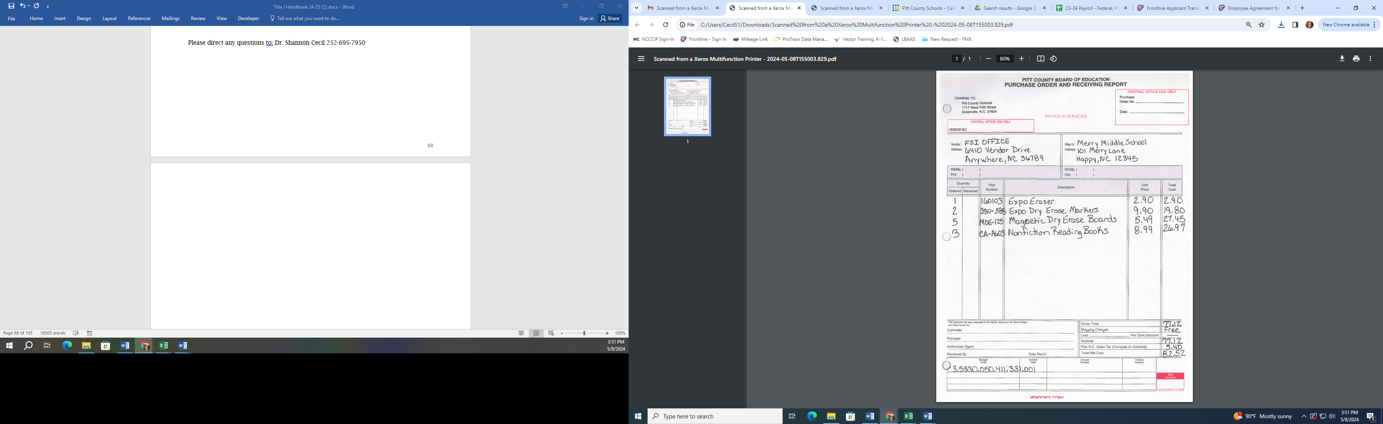

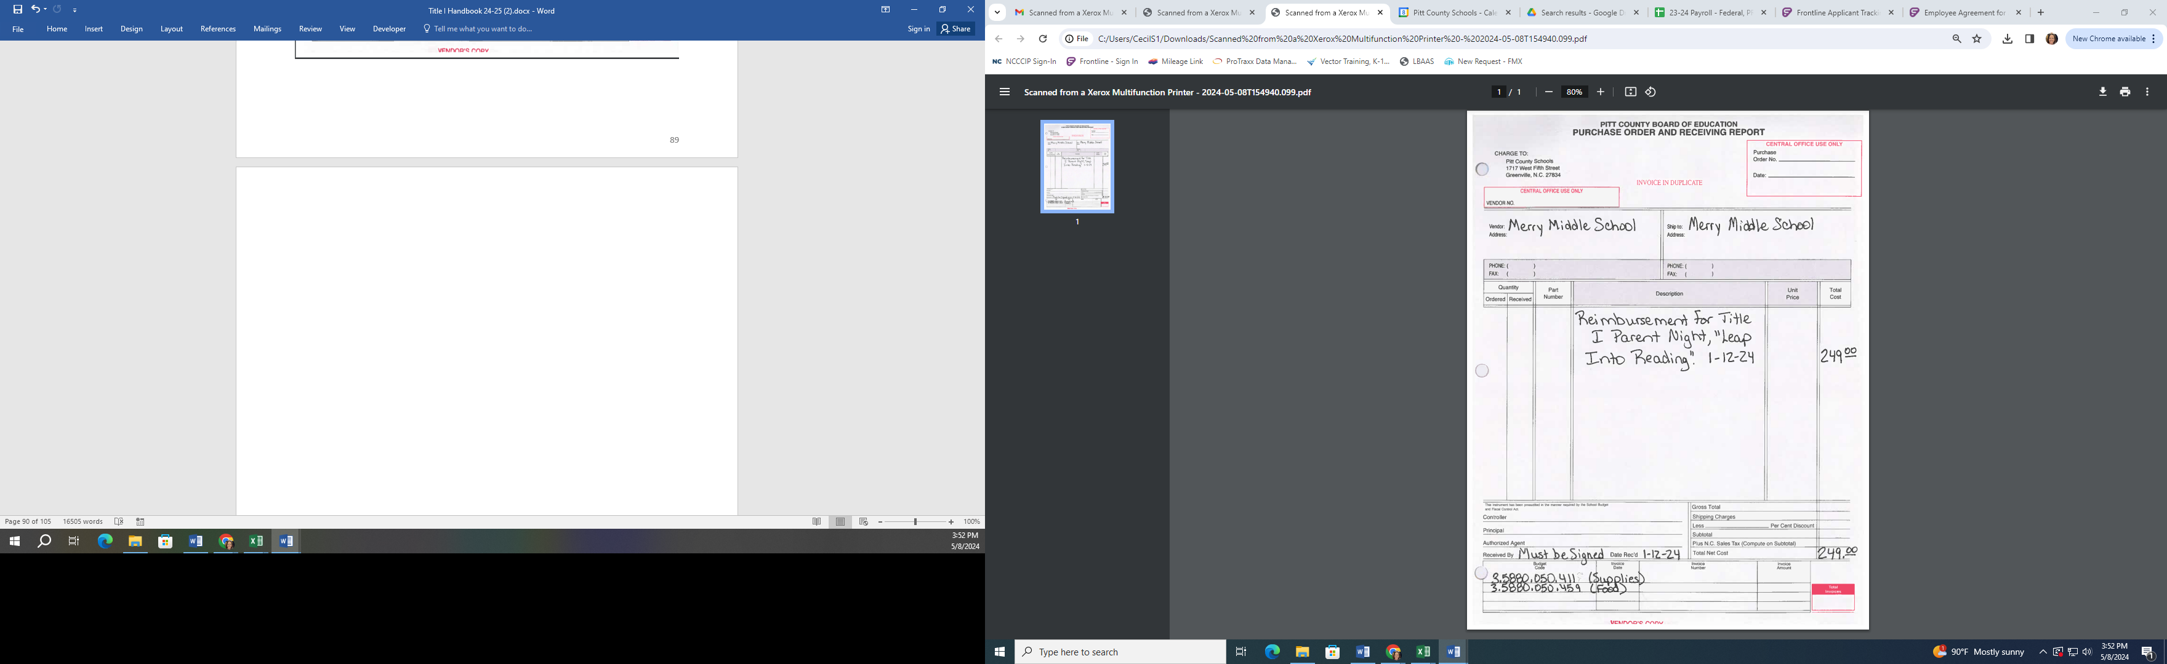

**Pitt County Schools**

**Estimate of Travel Expenditures Form**

**1. Employee Name:** _________________________________________________________________

**2. Meeting:** _________________________________________________________________

**3. Location:** _________________________________________________________________

**4. Date of Travel:** _________________________________________________________________

**5. Estimated Travel Expenditures:**

**Registration: ____________________**

**Meals (State Rate): ____________________**

**\*Room (incl tax): ____________________ ____** Nights at $_____per night

**Transportation/ ____________________**

**Mileage:**

**Air Fare:** ____________________

**Substitute Cost:** ____________________

**Other Expense:** ____________________

**Total:** ____________________

**Budget From Which Travel is to Be Paid:** _________________________________________________________

**\*If room rate exceeds allowable state per diem rate, please explain in detail reason why.**

____________________________________________________________________________________________________________________________________________________________________________________________________________________________________________________________________________________________________________________________________________________________________________________

**6. *Travel Approval – This is a true and accurate estimate of expenses to be incurred in the service of***

***Pitt County Board of Education.***

**Employee Signature: _____________________________**

**Date: _____________________________**

**Authorizing Signature(s): _____________________________ __________________________**

**Date: _____________________________ __________________________**

**\*Superintendent Sig. _____________________________**

**Date: _____________________________**

**\*Superintendent Signature is required if:**

**1. Estimated Total Travel Expense if $1,000 or more.**

**2. Superintendent is the immediate supervisor of the employee requesting**

**out of county travel.**



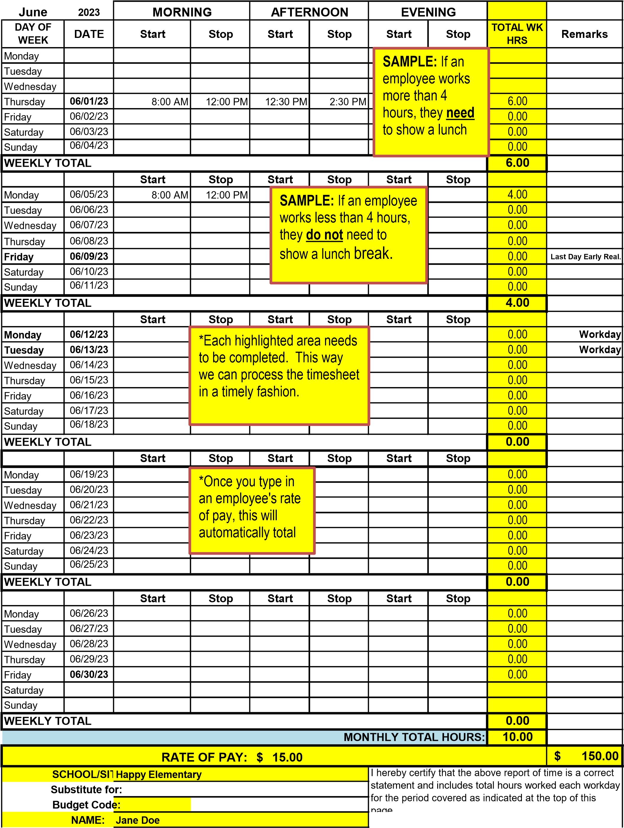

|  |
| --- |
| **School Name: Year:** |

**NCLB Parental Family Engagement Policy Requirements**

**& School Parental Involvement Plan Worksheet**

|  |
| --- |
| **Section 1118 of the ESEA Waiver formally replacing No Child Left Behind Act (NCLB) requires the involvement of parents of participating children in the planning and implementation of District and School Title I projects. Such programs, activities, and procedures shall be planned and implemented with meaningful consultation with parents of participating children.** |

* Each school must offer a minimum of 4 parent activities/meetings.

**\*Schools must have 5 or more parents (who are NOT PCS employees) attending in order to be reimbursed.**

* Using the descriptions below, create your school’s Parental Involvement Policy.
* Distribute the Parental Involvement Policy to all faculty and staff at the start of the year (Student/Staff Handbook);
* Distribute the Parental Involvement Policy to all parents at the start of the year;
* Distribute the Parental Involvement Policy to parents of newly enrolled students during the year; and
* Copies of your Parental Involvement Policy must be available in the front office (flyers, brochure, etc).
* Parent Engagement Plan must include, in detail, how you will meet each policy requirement by answering the attached questions (See questions A-F and 1-15).
* As documentation is collected and completed, add documentation to Title I website folders.
* Review Statement of Assurance with completed signatures for each school.

**A. List the names and roles (teachers, administrators, parents, etc.) of persons involved in developing your school’s Parental**

**Involvement Policy (you may add more lines if needed). – A parent is a REQUIRED member of this team.**

|  |  |
| --- | --- |
| **Name** | **Role** |
|  |  |
|  |  |
|  |  |
|  |  |
|  |  |
|  |  |
|  |  |
|  |  |
|  |  |
|  |  |

**B. Please complete the attached matrix about Parent Involvement at your school. Remember to include parents and staff**

**When completing this plan.**

**Parent Family Engagement Plan**

**School: __________________________________ Year: __________________________**

**\*Section 1118C – Documentation may include invitations, meeting agendas, sign-in sheets, minutes, calendars, etc.**

**\*Each school jointly develop with, agree and distribute to parents, a written parental involvement policy must specify how the school address each of the following required components:**

|  |  |  |  |
| --- | --- | --- | --- |
| **Requirements** | **Date(s)** | **Events/Activities** | **Documentation** |
| * Annual Meeting at a convenient time, to inform parents of their school participation in Title I and explain the requirements of the Title I program |  |  |  |
| * Explain how parents are involved in supporting Parent Involvement Policy and Comprehensive School Plans |  |  |  |
| * School’s responsibility to provide high-quality curriculum in a supportive and effective learning environment. How do you inform parents about the PCS School-Parent Compact |  |  |  |
| * Communication between teacher and parents on an on-going basis about child’s achievement, progress reports or opportunities to volunteer. Explain your school process. |  |  |  |
| **Requirements** | **Date(s)** | **Events/Activities** | **Documentation** |
| * Parent engagement training that support parents in helping their child at home   * List parent workshops |  |  |  |
| * Information related to school and parent programs,   How does the school present information to parents in a language that they understand? Provide full opportunities for participation of parent with English proficiency and parents with disabilities |  |  |  |
| * **Parent Communication:**   Explain how the schools enhance the home-school relationship and keeping them informed about school activities. Educate teachers and other staff how to work with parents |  |  |  |



**Example Elementary School**

**Title I**

**Parent Family Engagement Policy**

Section 1118 of the ESSA Waiver formally replacing ESEA requires the involvement of parents of participating children in the planning and implementation of District and School Title I projects. Such programs, activities, and procedures shall be planned and implemented with meaningful consultation with parents of participating children.

**This meeting is to inform parent about their rights under the law and to provide them with information that will allow them to be fully active in their child’s education.**

**To involve parents in the policy process we will:**

* Encourage all parents to attend the Example Meeting, held at the beginning of the year, to learn about Example School’s participation in Title I, the requirements of the Title I program, and your rights as parents to be involved.
* Hold Title I Parent Involvement meetings at different times and on different days, and may provide transportation, child care, or home visits to accommodate the scheduling needs of our parents.
* Involve parents in an organized, ongoing, and timely way in the planning, review, and improvement of Example School’s Title I programs, including the planning, review, and improvement of the school parental involvement policy and the joint development of the schoolwide program plan (if applicable).
* Provide parents with timely information about Title I programs, a description and explanation of the curriculum in use at Example School, the forms of academic assessment used to measure student progress, and the proficiency levels students are expected to meet.
* Upon request, provide parents with opportunities for regular meetings to formulate suggestions and to participate, as appropriate, in decisions relating to the education of their children, and respond to suggestions as soon as possible.
* If Example School’s schoolwide program plan (if applicable) is not satisfactory to the parents, we are required to submit any parent comments on the plan to Pitt County Schools Federal Programs Office.

**To share responsibilities for high student academic achievement we will:**

* Develop with parents, a school-parent compact that outlines how parents, school staff, and students will share responsibility for improved student academic achievement.
* Help parents create a supportive and effective learning environment at home by providing information on the importance of attendance, homework completion and the positive use of extracurricular time; limiting time spent watching television and playing video games; and volunteering in their child’s classroom and participating in decisions relating to the education of their children.
* Address the importance of communication between teachers and parents through parent-teacher conferences, progress reports, and provide reasonable access to staff, opportunities to volunteer and participate in their child’s class, and observe classroom activities.
* Parent Meetings will be held throughout the year, which gives parents a chance to be actively involved in their child’s education.

**To build capacity for involvement we will:**

* Ensure effective involvement of parents and support partnerships among the Example School, our parents, and our community to improve student academic achievement.
* Provide assistance to parents in understanding topics such as the State’s academic content standards, the State’s student academic standards, State and Local assessments, the requirements of Title I, and how to monitor your child’s progress and work with educators to improve the achievement of your children.
* Provide parents with materials and training, such as literacy materials and technology training, to help them work with their children to improve their achievement, and to foster parental involvement.
* Educate teachers and school staff about the value of the contributions of parents; how to reach out to, communicate with, and work with parents as equal partners; implement and coordinate parent programs; and build ties between the parents, the school, and the community.
* Coordinate and integrate Title I parent programs and activities with other programs, and conduct activities and provide resources that encourage and support parents in more fully participating in the education of their children.
* Ensure that information related to school and parent programs, meetings, and other activities is sent to parents in a format and to the extent practicable, in a language the parents can understand.
* Provide other reasonable support for parental involvement activities as requested.

**To be accessible to all parents we will:**

* Provide full opportunities for the participation of parents with limited English proficiency, parents with disabilities, and parents of migratory children.
* Provide information related to Pitt County Schools, Example School, plans, meeting notices, report cards, and other accountability information in a format, and to the extent practicable, in a language that parents understand.

**Example Elementary School Title I Program Description:**

Example Elementary School operates a school-wide Title I program; as such, all students receive Title I services regardless of financial status. A group consisting of administration, teachers, support staff, and parents developed example Elementary’s Title I plan and policy. Our Title I program is based upon the information in our yearly needs assessment, which is completed prior to the start of each new school year.

Our Title I program will be implemented in accordance with the guidance provided by the Federal government. This includes providing the policy, to all students and their families in our school. Copies of our plan will be made available in our main office as well as being posted on our school website and social media pages.

**Sample Elementary Brochure**

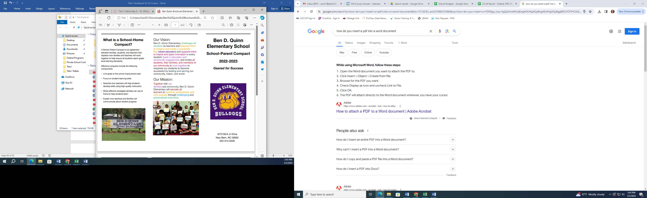

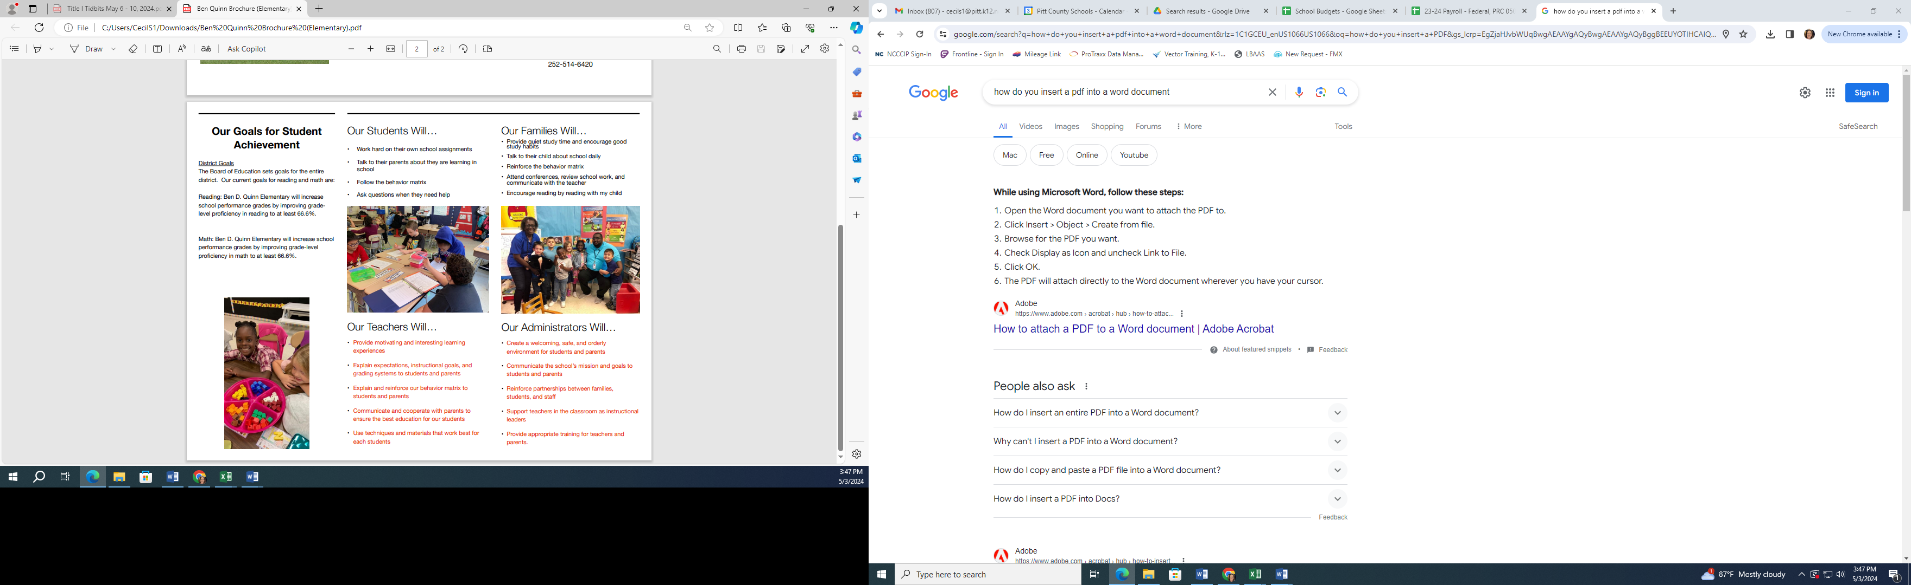

**Sample Middle School Brochure**

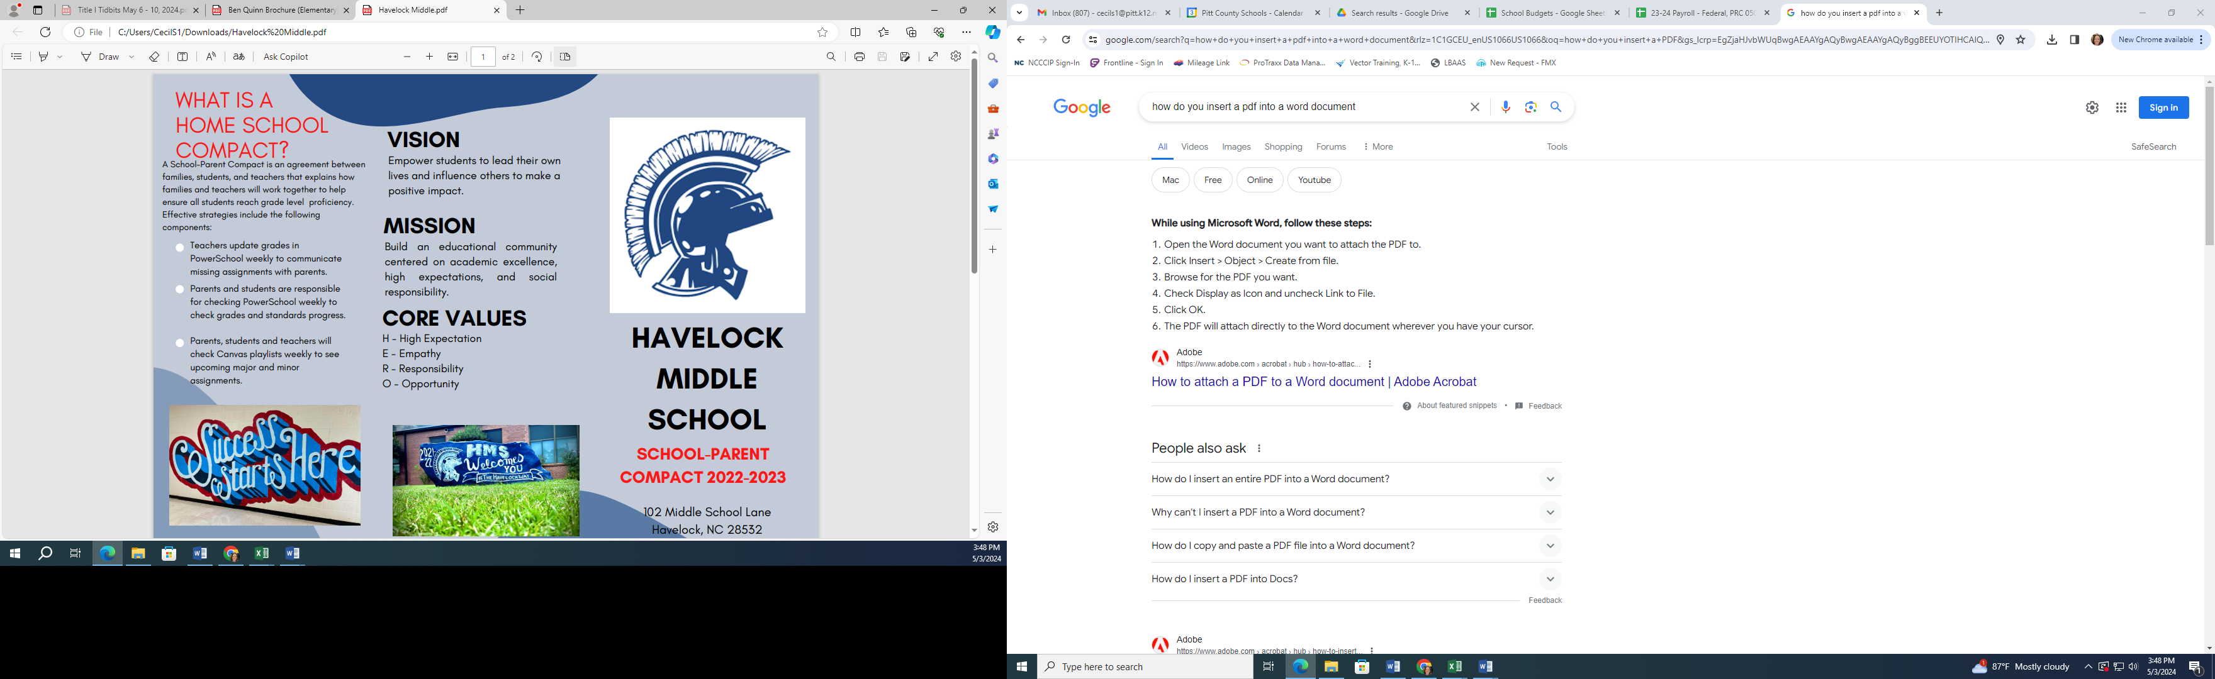

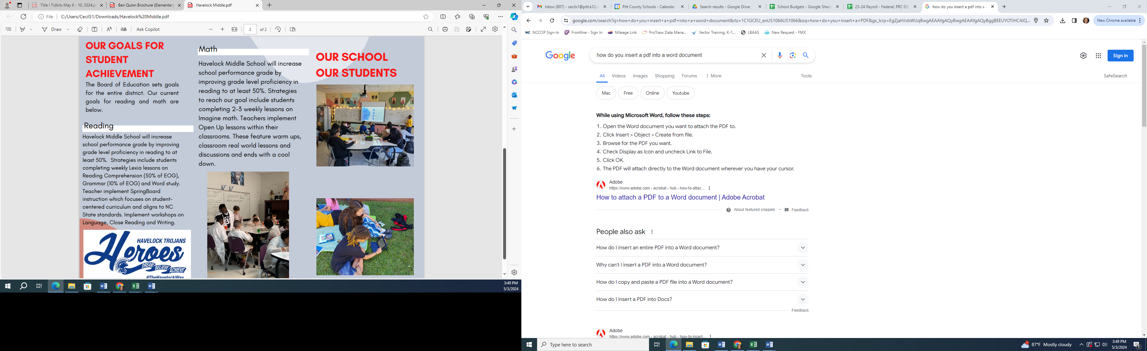

**Pitt County Schools**

**Title I Parent Meeting Sign-In Sheet**

**Name/Topic of Meeting: ________________________________________________________**

**Date of Meeting: _________________________ Time: _______________________**

|  |  |
| --- | --- |
| **Student’s Name** | **Parent/Guardian’s Name** |
|  |  |
|  |  |
|  |  |
|  |  |
|  |  |
|  |  |
|  |  |
|  |  |
|  |  |
|  |  |
|  |  |
|  |  |
|  |  |
|  |  |
|  |  |
|  |  |
|  |  |

Other Members (Teachers, Support Staff, Administration, etc.)

1. ________________________________ 2. ________________________________

3. ________________________________ 4. ________________________________

5. ________________________________ 6. ________________________________

7. ________________________________ 8. ________________________________

9. ________________________________ 10. ________________________________

Submitted by: ____________________________________________________________



**Pitt County Schools**

**Sample parent engagement evaluation**

**2024 - 2025**

**Dear Parent/Guardian,**

**We are always trying to improve our partnership with parents. Please help us by completing this form and return the completed form to your child's teacher. Thank you for your assistance.**

1. **How did you receive information about programs at your child’s school?**
2. **Did you observe/visit your child during the year in his/her classes? _____Yes _____No**
3. **What grade is your child in? ___________**
4. **Did you attend any meetings or parent sessions at your child’s school? (ex: Title I Night, Math Night, Reading Night, STEM Night, etc.) _____Yes _____No**
5. **What is the best time for meetings to be held so you are able to attend? ________________**
6. **If you attended any meetings, did you find them helpful? _____Yes _____No**
7. **Have you been contacted by your child’s teacher this year? _____Yes _____No**
8. **What methods of communication have been most effective? (ex: phone, email, flyers sent home, etc)**
9. **Were you asked to review and provide input into your school’s Parent/Student/School compact? _____Yes _____No**
10. **Was the information you received in a language you could understand? _____Yes _____No**

**LOOKING AHEAD**

**What topic(s) would you like to have discussed at a future parent meeting?**

**How can we improve our programs for next year?**

**Thank you again for your assistance in completing this form and returning it to your child’s teacher.**